CODI Manufacturing’s Gantry Palletizers Deliver
High Performance at a Low Cost

The new Flex Stack series outperforms cobot palletizers
in every way.

LITTLETON, Colo., (date) — CODI Manufacturing introduces at Pack Expo a new series of gantry palletizers that compare in price to cobot palletizers but offer higher performance and lower total cost of ownership. The new Flex Stack series is based on world-class Festo mechatronic technology and is displayed at the Festo Pack Expo booth. (Festo Pack Expo Booth #N-9018, September 29-October 1, Las Vegas Convention Center)
While attention today seems focused on the low cost of acquisition for cobot palletizing solutions, gantry palletizers and depalletizers deliver a host of advantages over cobots and light payload industrial robots, including:
- Higher payloads and superior workspace coverage
- Higher speed and cycle rates
- Minimized space requirements
- Traditional safety, high-speed operation
- Simple linear mechanics for less wear and high reliability
- Simplified maintenance and low-cost spare parts
- Customizable and expandable for different production volumes

The CODI Manufacturing Flex Stack series palletizers are offered in multiple standard load capacities, the first up to 44 lbs and the second up to 66 lbs. The Flex Stack Pro series is a customizable solution and has a load capacity of up to 110 lbs. The Flex Stack series operates at 4 to 10 boxes per minute. CODI plans to offer tier sheets with glue options.
To demonstrate the flexibility of Flex Stack Pro customization, CODI built its Pack Expo showcase machine as a twin-pallet palletizer for high-throughput operations – when one pallet is being loaded, the other discharges. The Flex Stack is also ideal for de-palletizing and for palletizing mixed product pallets.
Jared Jones, COO, CODI, says return on investment (ROI) in one year is doable for operations switching from labor intensive palletizing to an automated Flex Stack option. The new Flex Stack series offers simple operation and maintenance, versatility, safety, and decreased labor. The series is tailored to each customer’s needs to reduce labor and increase the integrity of pallet loads across many industries, including third-party logistics (3PL) operations, food, beverage, and consumer goods companies. Gantry palletizers require less floor space than manual palletizing and reduce ergonomic/worker compensation issues.
Flex Stack units can be skid-mounted and moved via pallet jack or forklift. CODI offers customers the option of the new Festo AX Motion Insights Electric and Pneumatic subscription-based predictive analytics packages to increase uptime and throughput while lowering inventory. “For high-speed operations, knowing what components are doing in real time is invaluable for planned preventive maintenance in order to avoid interrupting production,” Jones said. “Customers can order motors, drives, and cylinders before they fail and do not have to stock them in inventory.” CODI also offers customers the option of the new Festo AX Data software, which enables the IT department to access data from operational technology.
The new Festo palletizing software installed on Flex Stack palletizers features a choice of an intuitive, easy-to-use web browser interface (Chrome, Edge, or Firefox) that doesn't require programming knowledge. There is a one-click auto-generate function to calculate optimal pack patterns. Automatic plausibility and limit-value checks are built in to ensure the pack pattern is functional. Users gain a 3D view of the pallet that can be rotated and zoomed for visual checks. Users can reposition packaged goods using a mouse. This system ensures operators are aware of the necessary interventions. The software enables convenient and easy changes to process details and monitors and records the status of the palletizing process.
Flex Stack mechatronics feature Festo rugged axes, multiprotocol servo drives, motors (Z-axis motor, including a brake), hybrid controller, operator interface and vacuum technology. The units feature Festo’s new generation, backplane-speed CPX-AP-A remote digital I/O. Flex Stack lowers risk as the catalog-based components are available, interoperable, and globally supported by Festo.
Stop by the Festo Pack Expo Booth #N-9018 to see CODI Manufacturing’s Flex Stack Pro in action. Contact Jared Jones at www.codimfg.com/contact for information on the Flex Stack series of gantry palletizers. Visit www.codimfg.com for information about the company’s products and innovative machine-building services.
###
Download image here

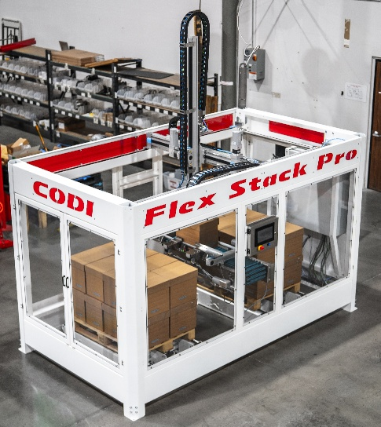
The new Flex Stack series of gantry palletizers/de-palletizers is based on world-class Festo mechatronic technology and is displayed at the Festo Pack Expo 2025 booth #N-9018.

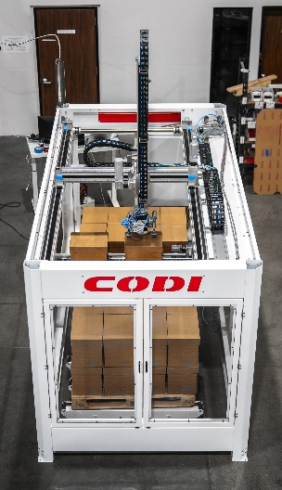
Return on investment (ROI) in one year is doable for operations switching from labor intensive palletizing to an automated Flex Stack option.

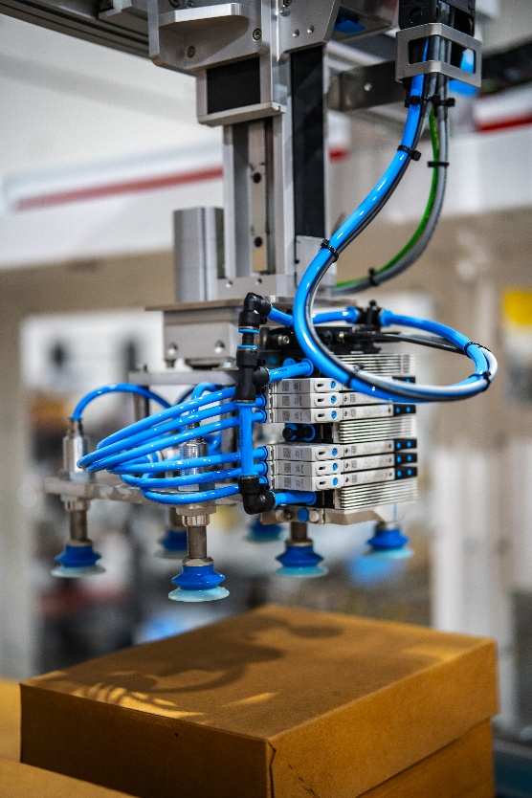
Festo VTUX compact valve manifolds, center, are placed on the end of arm tool for higher performance. VTUX features integrated vacuum with sensors for minimum energy consumption.

About CODI Manufacturing

For more than 30 years, Codi Manufacturing has provided packaging solutions to the food, beverage, and consumer products industries. From its beginnings in a 5,000 sq. ft. rented warehouse to the newly built 100,000 sq. ft. facility in Littleton, Colorado, CODI has always developed innovative solutions to customers’ needs. CODI Manufacturing innovates and is not satisfied unless it is expanding automation solutions for its global customers. www.codimfg.com

About Festo U.S.
Festo is a leading manufacturer of pneumatic and electromechanical systems, components, and controls for process and industrial automation. For 100 years with more than 50 in the U.S., Festo Corporation has continuously elevated the state of manufacturing with innovations and optimized motion control solutions that deliver higher performing, more profitable automated manufacturing and processing equipment. Through advanced technical and industrial education, Festo Didactic Learning Systems and its partners prepare workers for current and future manufacturing technologies.
Connect with Festo: Facebook, LinkedIn, and YouTube

