Festo gives the future of safe automation a hand

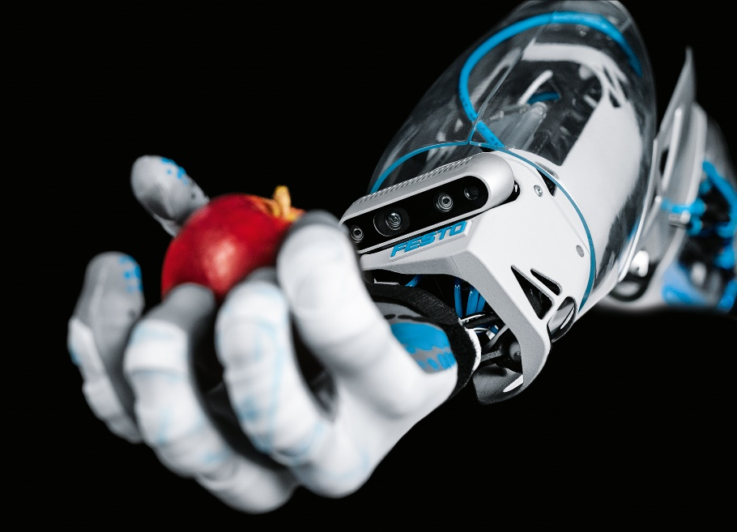

BionicSoftHand 2.0 uses a combination of compact valve technology, sensors, electronics and mechanical components to emulate the movements of a human hand.
Date
23/07/20
Our reference
FTO032

Press Information
Industrial change has accelerated, demanding a new level of interaction between people, machines and data. Within its Bionic Learning Network, Festo has been studying and developing safe automation systems to relieve people of monotonous or hazardous tasks. The BionicMobileAssistant is a prototype robot system that deploys artificial intelligence to move independently, identifying and gripping objects and adaptively working with humans.

The entire system has been developed in collaboration with ETH Zurich. It has a modular design consisting of three subsystems: a mobile robot, an electric robotic arm and a pneumatic gripper – the BionicSoftHand 2.0 – an earlier version of which was first presented by Festo in 2019. It uses a combination of compact valve technology, sensors, electronics and mechanical components integrated in the tightest of spaces in order to emulate the movements of a human hand.

BionicSoftHand 2.0 wears a tactile glove with force sensors on the fingertips, the palm and the outer sides of the robot hand. This allows it to sense the nature of the item to be gripped, and to adapt its gripping force accordingly – just as the human hand does. Thanks to a 3D-printed wrist with two degrees of freedom, the hand can also move both back and forth as well as to the left and to the right. This means that gripping smaller objects is now possible. In addition, the hand has a depth camera on the inside of the wrist so it can visually detect the objects to be gripped – even if these are partially obscured. The information is processed by a neural network, which has been trained in advance with the aid of data augmentation. Once the hand has been correctly trained, it uses the intelligence gathered to assess objects.

The system would be perfect for differentiating good product from bad product, or for use as a personal assistant: for example as a service robot helping in assembly or assisting workers in carrying out ergonomically monotonous tasks. It could also be used in environments where people cannot work because of hazards or restricted accessibility. This includes maintenance or repair work, data measurements or visual inspections. It is also possible to imagine mobile robots carrying out tasks in areas where there is an increased risk of infection: delivering medicines to hospital patients, supporting the delivery of care in old people’s homes, or waving ultralight sterilising wands within wards.

To see the BionicMobileAssistant in action visit www.festo.com/bionicmobileassistant

ENDS

The press text and photo(s) can be downloaded from www.festo.co.uk/press

Additional images and captions

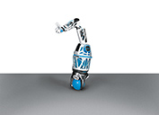

The robotic arm balances on a ball, enabling it to move freely in all directions.

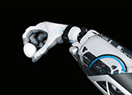

The BionicSoftHand 2.0 senses the item to be gripped and adapts its gripping force accordingly – just as people do.

About Festo
Festo is a leading international supplier of automation technology with a turnover in 2019 of around €3.1 billion. Festo employs over 20,100 people worldwide and is a proven innovator and problem solver in the field of pneumatic and electrical automation where it has established itself as the performance leader. Festo offers around 32,000 pneumatic and electric products in several hundred thousand variants for factory and process automation technology which can be tailored to specific customer needs in a variety of modular programs.

Festo Industrial Automation’s innovative strength is demonstrated through the introduction of around 100 new products being launched every year. The company invests over 8% of its turnover in R&D resulting in over 2,600 patents held worldwide. For more information about the company’s products and UK and Irish services, please visit: www.festo.com/gb and www.festo.com/ie

Festo and Industry 4.0 - Festo has engaged with the Industry 4.0 initiative from its inception: as a user, manufacturer and trainer. Appointed by the German government as a member of the steering group the company has taken an active role in the definition of the core standards such as the RAMI model and the Administration Shell. Festo Didactic has also developed the Industry 4.0 Cyber-Physical Factory training hardware installed in many leading universities and training centres, as well as Industry 4.0 training courses covering the strategic overview for change managers and practical workshops for employees. Industry 4.0 technologies such as OPC-UA communications are embedded in the latest generation products. For more information go to www.festo.co.uk/I40

Festo Training & Consulting delivers training for industry – by industry. Combining Festo’s industrial heritage with its future-focused manufacturing and engineering expertise to create courses that deliver greater productivity and competitive advantage to businesses. Offering a range of open courses, structured development programmes and tailor-made, customer-specific projects on technology, Industry 4.0 and People & productivity. More information on the training and consulting services can be found at: www.festo-didactic.co.uk

Festo’s Bionic Learning Network encapsulates the innovative nature of Festo, raising awareness and attracting talent to the company. Exploring the links between nature and technology opens new areas of innovation and demonstrates complex ideas in a stimulating and enjoyable way. Festo works with an alliance of internal R&D, external educational establishments and specialist companies, to advance the development of bionic solutions for automation applications of the future. The objective is to benefit from bionics as a source of inspiration for new technologies and to realise these in industrial automation. For more information about Festo’s Bionic Learning Network, please visit: www.festo.com/bionics

For more information please visit www.festo.com

Telephone number for publication: - 01252 775000

Journalist contact:
Alison Jones, Publitek
Tel: 01582 390980
Email: alison.jones@publitek.com

