PCE Automation uses Festo technology to put STANLEY® knife production at the cutting edge
Date
04.02.21
Our reference
FTO028

Press Information
Festo automation technology is being used to help STANLEY® Tools in the UK to meet continued demand for its renowned safety knives, while continuing to maintain the highest standards of safety and quality.

Festo automation sits at the heart of a new rotary assembly cell designed and supplied by PCE Automation Ltd. The new production cell also contains Festo mini slides, axes, cylinders, valves and grippers – all of which contribute to the high precision alignment required for STANLEY knife assembly.

Josh Roberts, Festo Business Development Consultant, says: “The STANLEY knife rotary assembly cell presents a great example of how automation can be applied to replace manual repetitive tasks and deliver benefits, such as improved productivity and quality.

“PCE involved Festo at the earliest possible stage, which meant we could work in partnership and combine our respective specialist knowledge as system builders and automation specialists to deliver the optimum solution for Stanley Black & Decker.”

Cutting edge solution
The customer required an assembly cell that could be used to produce safety knives with two different sizes of blade capable of swapping production efficiently between their 9mm and 18mm width options. To meet demand, a cycle time of 20 parts per minute was necessary. In addition, Stanley Black & Decker needed a compact solution to fit in the existing footprint at their UK production facility.

PCE Automation Ltd won the contract to design and build the new automated assembly cell under competitive tender, against international competition. In partnership with Festo, they were able to demonstrate the levels of responsiveness and aftersales support that their customer was looking for.

Their solution is an eight-station rotary assembly cell featuring Festo automation. The blade handles are held in position on the central rotary assembly and the components, including blades, are placed with high precision to build up the final product. The fully assembled STANLEY knives are subject to camera inspection for quality control as they leave the cell on a conveyor.

The customer did not want the assembly cell to require constant overseeing by an operator. So, hoppers are used to feed components down to vibrating bowl feeders. The hopper feeds will keep the cell running for approximately one hour without the need for operator intervention. The bespoke vibrating bowl feeders were manufactured by PCE’s sister company Premier Bowl Feeders.

Introducing the knife blades into the assembly cell raised a particular challenge for PCE. The 9mm and 18mm length blades are presented to the assembly cell in stacks of 400, but each blade is only 0.4mm or 0.5mm thick, which makes them tricky to pick and place accurately. There was a real risk of the blades jamming and halting production if not correctly positioned, so it was critical to be able to pick off one blade at a time and place it in the correct orientation. PCE used magnets to hold the blades effectively. Festo grippers are used to pick and place all the other components.

The nerve centre of the new rotary assembly cell is the Festo CPX-AP-I (see box-out), which acts as a single control network and facilitates the use of a single cable for all communications and power. It also allows flexible positioning of valve terminals and other components around the assembly cell – all of which simplifies installation and lowers overall cost. Festo DGST precision mini slides and grippers are used for accuracy and repeatability in presenting the plastic components for assembly. These are complemented by DFM guided actuators and air preparation units from Festo’s core Blue Star range of best priced and availability, pneumatics.

Ellen Blackie, Senior Project Manager, PCE Automation, comments: “As an existing Festo Integrator, we had every confidence that their product portfolio would offer the quality and precision that the STANLEY knife assembly application demanded. Breadth of product choice, coupled with Festo’s on time delivery record and parts availability, were critical in helping us win the Stanley Black & Decker contract. As a systems builder, we appreciate the proactive support that Festo offers in exploring alternative solutions. We also found their online software tools particularly helpful, especially the ability to track parts and lead-in times online.”

www.festo.co.uk
www.pce-automation.co.uk

Ends
BOX-OUT – Festo CPX-API automation platform

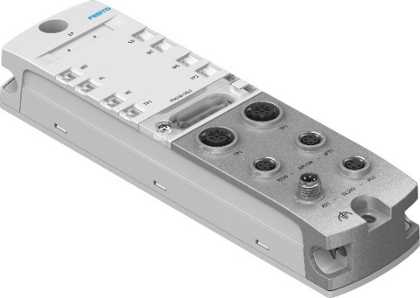
CPX-AP-I is a decentralised IO system that provides seamless connectivity from the field level right through to the cloud, making digitalisation incredibly easy. It integrates IO Link, high speed data transfer to the cloud and intelligent connectivity to the host PLC in one simple package. This allows integration of I/O link masters and valve terminals into major host systems in a flexible and scalable way, no matter which industrial automation network is being used.

The system is based on Festo’s new Automation Platform (AP). Essentially, it consists of a fieldbus module which will connect to networks such as PROFINET, PROFI-BUS, Ethernet/IP, Mod-bus and EtherCAT®, ensuring that customers can integrate the system irrespective of their host PLC of choice. Below this fieldbus module, the system then becomes standard and communicates on the Festo Automation Platform. Offering genuine network neutrality, CPX-AP-I therefore ensures that customers can maintain a standardised architecture and bill of materials, with all I/O seen transparently as being on the host network – irrespective of the customer’s choice of PLC.

CPX-AP-I is sturdy, compact and ultralight, making it ideal for assembly machines with limited installation space – such as the STANLEY knife application. It is also suited to handling and tool change systems, or mobile applications where low weight and small installation space are called for.

For Festo’s latest news go to www.festo.co.uk/gbpress

Images and captions:

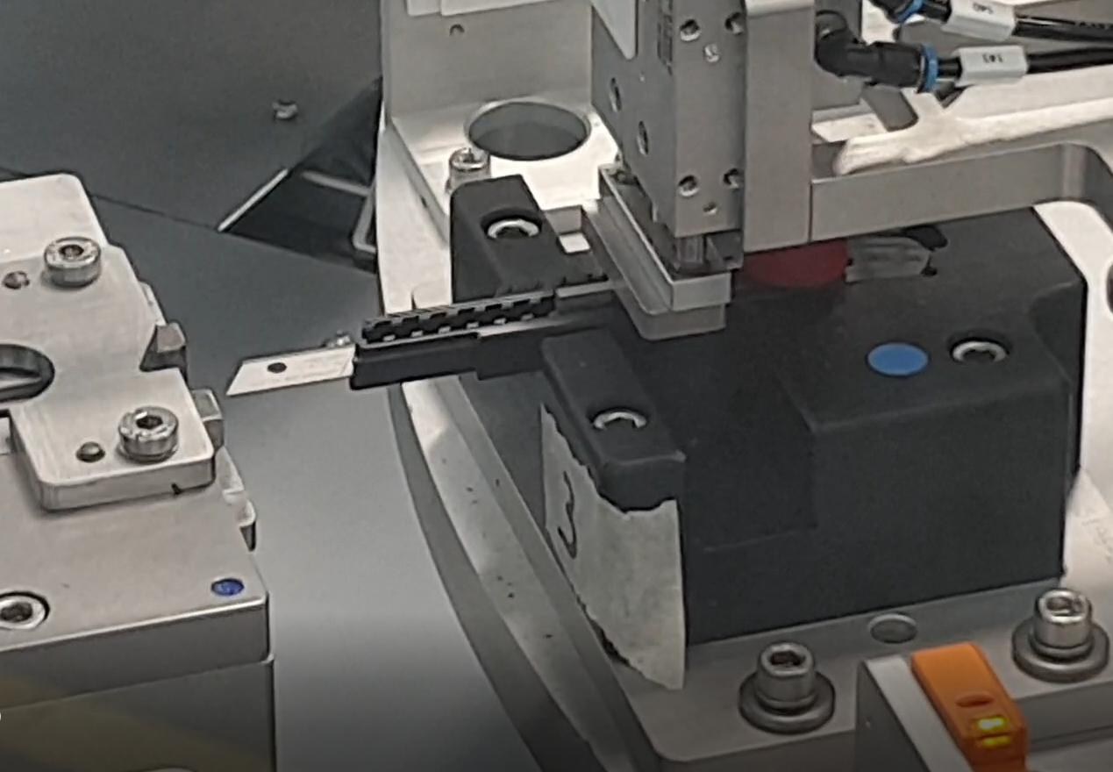

STANLEY safety knives are being produced more rapidly and without loss of quality using a PCE Automation rotary assembly cell featuring Festo technology.

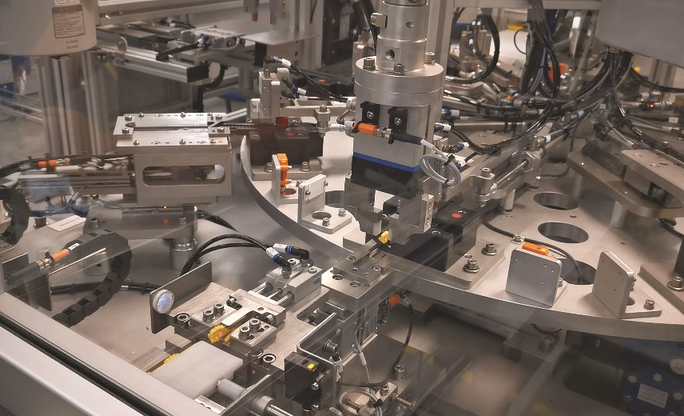

A combination of Festo DGST mini-slides, axes, cylinders and grippers are used to pick and place the STANLEY knife components with high precision and repeatability.

About STANLEY

STANLEY, a brand of Stanley Black & Decker, Inc. is a diversified manufacturer of innovative tools and engineered solutions for professional, industrial, woodworking, construction, automotive repair, organizational, and do-it-yourself use. Since 1843 STANLEY has consistently provided solutions that make life easier with reliable hand tools. Headquartered in New Britain, CT, STANLEY is committed to manufacturing tools in the USA with global materials. Annually, STANLEY produces a large variety of hand tools including tape rules, knives, blades, hand saws, screwdrivers, plastic storage, and accessories in multiple manufacturing locations in North America. STANLEY can be found internationally wherever tools are sold and has helped build America with a breadth of quality hand tools people can trust for over 175 years. For more information visit www.stanleytools.com or follow STANLEY on Facebook, Instagram, and Twitter.

About PCE Automation Ltd

Formed in 1961, PCE Automation Ltd are at the forefront of UK Automation and UK Manufacturing, providing a vast range of bespoke turnkey automation solutions. PCE have built a worldwide reputation for innovation and quality, underpinned by ISO 9001 and Safe Contractor accreditations, as well as a Queens Award for Enterprise 2020 in International Trade.

PCE manufacture stand alone and complete systems primarily for clients within the ocular, medical, pharmaceutical, clean room/laboratory and FMCG (Fast Moving Consumer Goods) sectors, as well as Industrial Automation. PCE can boast complete in-house skills and capabilities to design, project manage, manufacture, program, install, commission and service; meaning shorter project lead times through reduced outsourcing, helping customers achieve a swifter ROI.

PCE Automation is a founding member of the PCE GROUP of Companies. For more information, visit: www.pce-automation.co.uk

About Festo
Festo is a leading international supplier of automation technology with a turnover in 2019 of around €3.1 billion. Festo employs over 20,100 people worldwide and is a proven innovator and problem solver in the field of pneumatic and electrical automation where it has established itself as the performance leader. Festo offers around 32,000 pneumatic and electric products in several hundred thousand variants for factory and process automation technology which can be tailored to specific customer needs in a variety of modular programs.

Festo Industrial Automation’s innovative strength is demonstrated through the introduction of around 100 new products being launched every year. The company invests over 8% of its turnover in R&D resulting in over 2,600 patents held worldwide. For more information about the company’s products and UK and Irish services, please visit: www.festo.com/gb and www.festo.com/ie

Festo and Industry 4.0 - Festo has engaged with the Industry 4.0 initiative from its inception: as a user, manufacturer and trainer. Appointed by the German government as a member of the steering group the company has taken an active role in the definition of the core standards such as the RAMI model and the Administration Shell. Festo Didactic has also developed the Industry 4.0 Cyber-Physical Factory training hardware installed in many leading universities and training centres, as well as Industry 4.0 training courses covering the strategic overview for change managers and practical workshops for employees. Industry 4.0 technologies such as OPC-UA communications are embedded in the latest generation products. For more information go to www.festo.co.uk/I40

Festo Training & Consulting delivers training for industry – by industry. Combining Festo’s industrial heritage with its future-focused manufacturing and engineering expertise to create courses that deliver greater productivity and competitive advantage to businesses. Offering a range of open courses, structured development programmes and tailor-made, customer-specific projects on technology, Industry 4.0 and People & productivity. More information on the training and consulting services can be found at: www.festo-didactic.co.uk

Festo’s Bionic Learning Network encapsulates the innovative nature of Festo, raising awareness and attracting talent to the company. Exploring the links between nature and technology opens new areas of innovation and demonstrates complex ideas in a stimulating and enjoyable way. Festo works with an alliance of internal R&D, external educational establishments and specialist companies, to advance the development of bionic solutions for automation applications of the future. The objective is to benefit from bionics as a source of inspiration for new technologies and to realise these in industrial automation. For more information about Festo’s Bionic Learning Network, please visit: www.festo.com/bionics

For more information please visit www.festo.com

Telephone number for publication: - 01252 775000

Journalist contact:
Alison Jones, Publitek
Tel: 07850 507319
Email: alison.jones@publitek.com

