Adopting an application-led approach to linear motion tasks resolves electric versus pneumatic dilemma, says Festo
Date
15.06.21
Our reference
FTO036

Press Information
Industrial automation specialist Festo claims that machine builders can resolve the age-old dilemma of whether to deploy electric or pneumatic technology for linear motion tasks by adopting a more application-led approach and deploying hybrid solutions.

Warren Harvard, Product Marketing Manager at Festo, explains: “Many machine builders think they need to make a decision between electric automation and pneumatic drives. Some claim that electric actuation is cheaper, more energy efficient and easier to work with. Others feel pneumatic technology is far more rugged, simpler and has a higher power density. But this ‘one or the other’ approach isn’t always helpful in meeting the needs of the application. It’s clearly better to have an efficient overall system rather than to focus on the efficiency of individual components.”

This principle is driving new advances in linear motion, with product manufacturers seeking to combine the advantages of both pneumatic and electric drives in a single solution. For example, the Simplified Motion Series (SMS) from Festo offers an affordable option that is easy to install and operate. There is no need for external servo drives installed in control cabinets because the whole device is mounted directly on the machine.

Their simplified set-up and operation makes SMS electric drives perfect for simple motions between two mechanical end positions, without having to sacrifice electric drive motion characteristics such as pre-defined speed, gently cushioned movement into end positions and selectable force for pressing or clamping functions. They can be simply and securely combined mechanically with other SMS actuators using more advanced electric axes from Festo, or the vast range of pneumatically-driven guided actuators using standardised interfaces and centring rings for accurate positioning and load transfer.

Festo’s free online sizing tool gives added assurance, not only enabling users to select and size their linear motion solutions quickly and accurately, but also to generate the required documentation and drawings for incorporation in their overall machine design.

Furthermore, these drives are equipped with IO-Link® as standard so they can be integrated seamlessly into fully digitalised environments: supporting predictive maintenance regimes and smart air consumption to make a full contribution to optimising production and energy efficiency.

Concludes Harvard: “Each industrial application has its specific requirements with regards to technical criteria: such as speed, acceleration, load capacity and force required, cycle time, holding duration, power to weight ratio, accuracy, control behaviour, torsional rigidity, efficiency or robustness. Pneumatic and electric drive solutions have traditionally offered specific advantages and disadvantages, but the advent of improved solutions such as the SMS Series mean that machine builders can opt for an alternative, more application-led, approach to finding a solution.”

The free online sizing tool and further resources about the Simplified Motion Series, including video demonstrations, are available here: www.festo.co.uk/sms

ENDS

For more information about Festo products and services, visit: www.festo.com/gb

The press text and photo(s) can be downloaded from www.festo.co.uk/gbpress

Images and captions

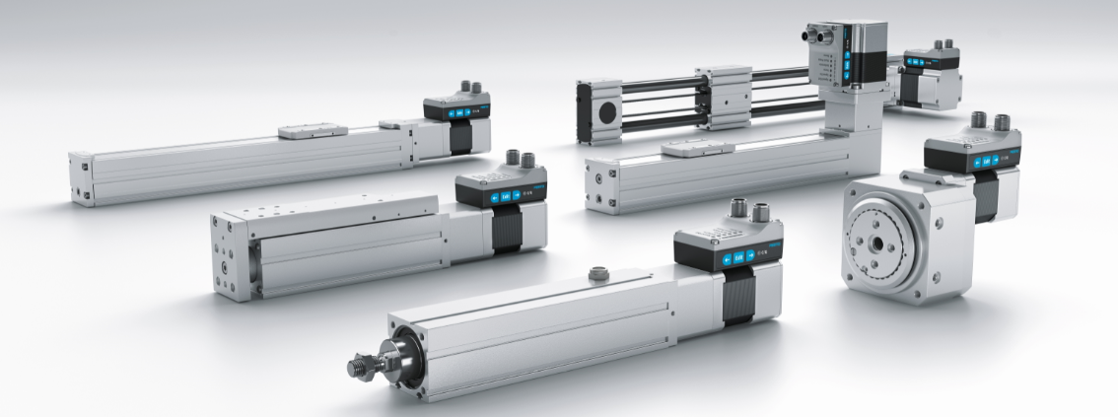

Simple electric drives that integrate the motion and control of electric drives in easy-to-use plug and work packages are a new option for linear motion applications.



Warren Harvard – Product Marketing Manager at Festo

About Festo
Festo is a leading international supplier of automation technology with a turnover in 2020 of around €2.84 billion. Festo employs over 20,000 people worldwide and is a proven innovator and problem solver in pneumatic and electrical automation, where it is the performance leader. Festo offers around 30,000 pneumatic and electric products in hundreds of thousands of variants for factory and process automation technology which can be tailored to specific customer needs. Sustainability, reducing its CO2 footprint, digital learning, innovation, performance and speed are the key drivers for the company's future.

Festo Industrial Automation's innovative strength is demonstrated through the launch of around 100 new products every year. The company invests over 8% of its turnover in R&D, resulting in over 2,600 patents held worldwide. For more information about the company's products and UK / Irish services, please visit: www.festo.com/gb and www.festo.com/ie

Festo and Industry 4.0 - Festo has engaged with the Industry 4.0 initiative from its inception: as a user, manufacturer and trainer. As a member of the steering group, the company has taken an active role in defining the core standards such as the RAMI model and the Administration Shell. Festo Didactic has installed Industry 4.0 Cyber-Physical Factory training hardware systems in many leading universities and training centres. It also provides Industry 4.0 training courses for change managers and practical workshops for employees. Industry 4.0 technologies such as OPC-UA communications are embedded in the latest generation products. For more information, go to digital.festo.com

Festo Didactic training delivers training for industry – by industry. Combining Festo's industrial heritage with its future-focused manufacturing and engineering expertise to deliver courses for greater productivity and competitiveness. Offering a wide range of open courses, structured development programmes and tailor-made, customer-specific projects on technology and Industry 4.0. In 2021 Festo launched the industry-leading online training suite, Festo LX. Festo also provides state-of-the-art training equipment solutions for 56,000 industrial companies and educational institutions around the world. More information on Festo training and consulting services can be found at: www.festo-didactic.co.uk

Festo Bionic Learning Network encapsulates the innovative nature of Festo, raising awareness and attracting talent to the company. Exploring the links between nature and technology opens new areas of innovation and demonstrates complex ideas in a stimulating and enjoyable way. Festo works with an alliance of internal R&D, external educational establishments and specialist companies to advance bionic solutions for automation applications of the future. The objective is to benefit from bionics as a source of inspiration and to realise these in industrial automation. For more information about Festo's Bionic Learning Network, please visit: www.festo.com/bionics

For more information please visit www.festo.com

Telephone number for publication: - 01252 775000

Journalist contact:
Alison Jones, Publitek
Tel: 01582 390980
Email: alison.jones@publitek.com

