Creating Digital Twins is quicker and error-free with Festo’s award-winning online product catalogue
Date
07.07.21
Our reference
FTO037

Press Information

Festo has developed an award-winning online catalogue that provides designers with a time-saving tool kit and prepares the way for the creation of an Asset Administration Shell, or Digital Twin, for their machines.

Preparing technical data for incorporation into Asset Administration Shells will become increasingly important for designers in the future, but the ability to collate complex data quickly and accurately also has relevance today in responding to the pressures and constraints of working under lockdown and recovery conditions.

Festo has been building on its digital product catalogue using eCATALOGsolutions technology from CADENAS for many years. Its achievements were recently recognised when Festo was awarded the CADENAS Golden Catalogue Seal for its comprehensive digital 3D CAD product catalogue. The Golden Catalogue Seal has been awarded to only 24 out of more than 800 catalogues in the Strategic Parts Management PARTsolutions as well as the 3D CAD download portal PARTcommunity.

"Thanks to CADENAS' technology, we can offer our customers CAD data in multiple file formats for more than 33,000 products in several hundred thousand variants," says Jürgen Herr, Head of Customer CAD and Digital Media at Festo. "In addition to pure CAD geometry, we place great emphasis on kinematics functions, discontinuation information, eCLASS classifications, product-specific links to our product catalogue, and seamless integration into product configurators during the creation process. As a result, we support our customers with consistent and high-quality CAD data even in the early stages of product selection and design."

Error-free product selection
The Festo online catalogue integrates a product configurator, automatic 2D dimensioning for CAD components, and product data in at least three languages. These features are independently checked by the CADENAS quality assurance department. Intuitive configurators facilitate product selection in addition to providing intelligent 3D CAD models as digital twins in over 150 common native and neutral CAD formats.

Engineers and designers can select their Festo components easily and quickly, while the software copes with the immense number of variants to combine them. For example, the Festo 3D Design Tool supports the assembly of sub-systems such as actuator + mountings + sensors + flow controls quickly and reliably with no chance of errors.

For standard part number components this eases a repetitive, time consuming task. For complex configurable assemblies it is all too easy to make mistakes that historically required correction in multiple locations e.g. CAD drawings, fluid-power circuit diagrams, general assembly drawings etc. The catalogue software supports systems such as customised air preparation systems, multi-module electro-pneumatic valve terminals and complete 3-axis cartesian handling systems.

Compiling technical documentation files is equally simple and error-free, whether the design involves off-the-shelf standard components or complex configurable sub-systems. This saves many hours or even days of time by bringing all the required data together in a digital, error-free format. Providing digital data in a standard semantic format lays the foundation for incorporation into an Asset Administration Shell the kernel of a Digital Twin.

For more information about Festo products and services, visit: www.festo.com/gb

Ends

The press text and photo(s) can be downloaded from www.festo.co.uk/gbpress

Images and captions:

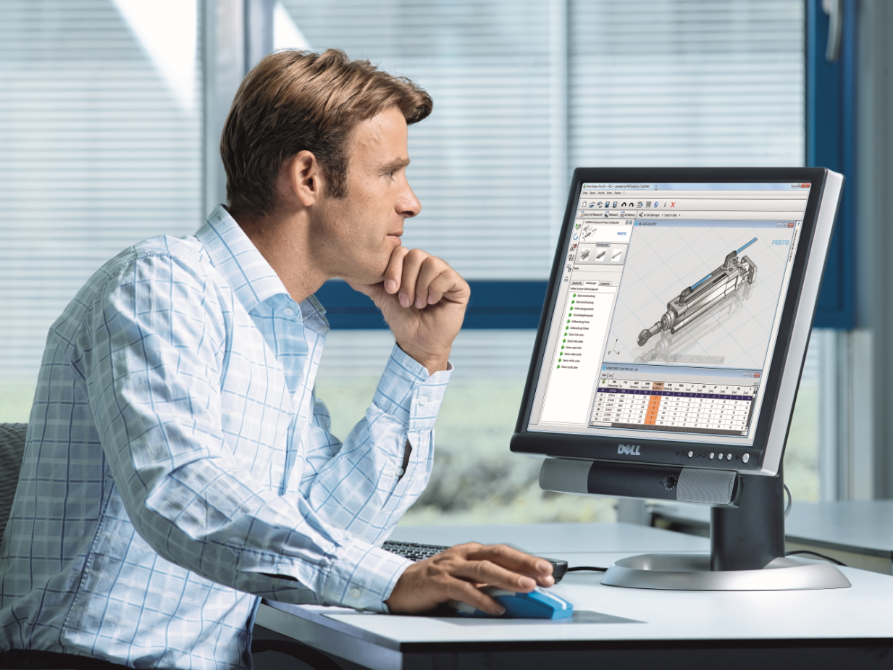

Festo has developed an award-winning online catalogue that saves time and prepares the way for the creation of an Asset Administration Shell, or Digital Twin.

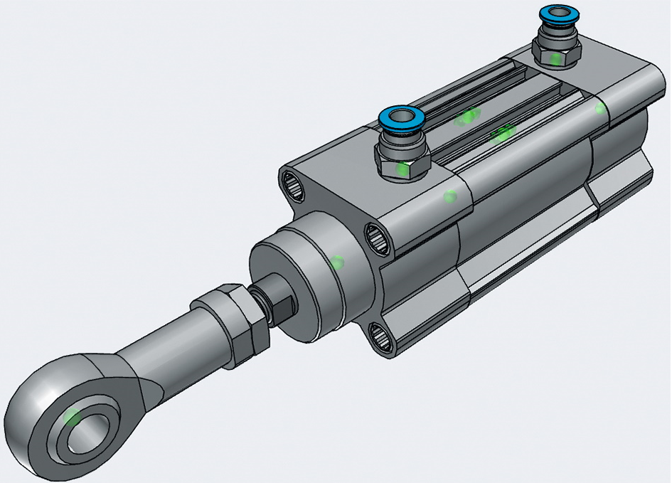

Example configuration using the comprehensive digital Festo 3D CAD product catalogue.

About Festo
Festo is a leading international supplier of automation technology with a turnover in 2020 of around €2.84 billion. Festo employs over 20,000 people worldwide and is a proven innovator and problem solver in pneumatic and electrical automation, where it is the performance leader. Festo offers around 30,000 pneumatic and electric products in hundreds of thousands of variants for factory and process automation technology which can be tailored to specific customer needs. Sustainability, reducing its CO2 footprint, digital learning, innovation, performance and speed are the key drivers for the company's future.

Festo Industrial Automation's innovative strength is demonstrated through the launch of around 100 new products every year. The company invests over 8% of its turnover in R&D, resulting in over 2,600 patents held worldwide. For more information about the company's products and UK / Irish services, please visit: www.festo.com/gb and www.festo.com/ie

Festo and Industry 4.0 - Festo has engaged with the Industry 4.0 initiative from its inception: as a user, manufacturer and trainer. As a member of the steering group, the company has taken an active role in defining the core standards such as the RAMI model and the Administration Shell. Festo Didactic has installed Industry 4.0 Cyber-Physical Factory training hardware systems in many leading universities and training centres. It also provides Industry 4.0 training courses for change managers and practical workshops for employees. Industry 4.0 technologies such as OPC-UA communications are embedded in the latest generation products. For more information, go to digital.festo.com

Festo Didactic training delivers training for industry – by industry. Combining Festo's industrial heritage with its future-focused manufacturing and engineering expertise to deliver courses for greater productivity and competitiveness. Offering a wide range of open courses, structured development programmes and tailor-made, customer-specific projects on technology and Industry 4.0. In 2021 Festo launched the industry-leading online training suite, Festo LX. Festo also provides state-of-the-art training equipment solutions for 56,000 industrial companies and educational institutions around the world. More information on Festo training and consulting services can be found at: www.festo-didactic.co.uk

Festo Bionic Learning Network encapsulates the innovative nature of Festo, raising awareness and attracting talent to the company. Exploring the links between nature and technology opens new areas of innovation and demonstrates complex ideas in a stimulating and enjoyable way. Festo works with an alliance of internal R&D, external educational establishments and specialist companies to advance bionic solutions for automation applications of the future. The objective is to benefit from bionics as a source of inspiration and to realise these in industrial automation. For more information about Festo's Bionic Learning Network, please visit: www.festo.com/bionics

For more information please visit www.festo.com

Telephone number for publication: - 01252 775000

Journalist contact:
Alison Jones, Publitek
Tel: 01582 390980
Email: alison.jones@publitek.com

