Grolsch bottling plant upgrade goes with a swing, thanks to Festo automation
Date
20.10.21
Our reference
FTO039

Press Information

New servo technology from Festo is helping Grolsch to put the iconic swing tops on its bottles of lager. The ‘swing-top transfer unit’ was custom-designed by Festo in conjunction with system integrator MCA Linear Motion Robotics and is installed at the Grolsch Enschede plant in The Netherlands.

The 'swing-top transfer unit' provides approximately 3,800 swing-top bottles per hour with a porcelain cap and rubber ring. Bottles without clips are fed in on one side, while the swing tops are fed in from the other side. Before the tops can be positioned, a sensor detects where the hole in the bottle neck is as the bottle rotates. On the basis of this measurement, the bottles are rotated into the correct position via a servo motor located underneath. Afterwards, the swing-top transfer unit positions the swing top while the bottle is rotated again so the swing top can first be pressed into one and then into the other hole. The finished bottles are then transported to the filling line.

One of the most important changes in the new design is the replacement of the two electric and parallel positioned axes that carry out the horizontal movement (X-movement) by a heavy duty EGC axis. This has a double guide that is actuated by new servo technology in the form of Festo EMMT servo motors.The EMMT compact servo motor has a single cable for both motor and encoder signals. This means it can generate a very low holding torque, enabling it to synchronise several axes, even during lower speeds. In addition, the EMMT has a digital, absolute displacement encoder (single- or multi-turn) and is available in protection classes IP40 and IP67.

The existing Siemens PLC with Profibus was upgraded to Profinet using the Festo CPX-E automation system. The CPX-E is used as a central controller for both the servo and stepper motors and is configured as an EtherCAT master and motion controller. This solution delivers the required speed, accuracy and dynamic response needed from the swing-top transfer unit.

The new controllers and Profinet system also make gathering data really easy. This is helpful for process optimisation, fault finding and predictive maintenance: all aspects that Grolsch will focus on in the future in order to increase machine reliability and availability and reduce costs.

Steven Groot Zevert, a maintenance engineer in this part of the Grolsch factories says of the end result: “Thanks to the great cooperation between system integrator and automation manufacturer the project has been managed quickly and efficiently. I only really needed to let them know my requirements. These were then translated into a new, future-proof design that fits into our own automation system and was also configured and commissioned professionally by Festo and MCA.

“Everything runs according to plan and that’s just as well, as next year the swing-top bottle celebrates its 125th anniversary and I think Grolsch will be paying some attention to that!”

For more information about Festo products and services, visit: www.festo.com/gb

Ends

The press text and photo(s) can be downloaded from www.festo.co.uk/gbpress

Images and captions:

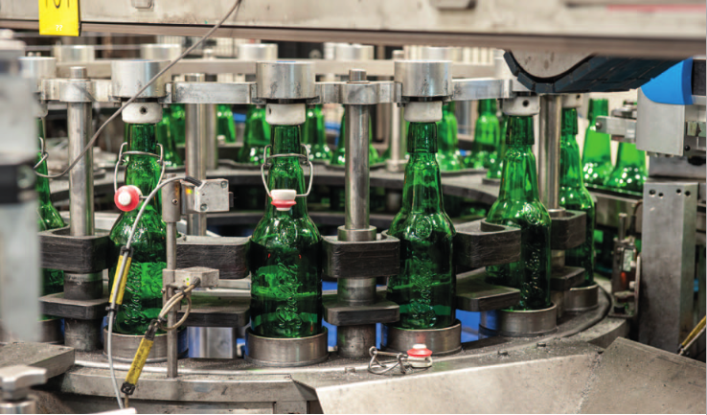

New servo technology from Festo is helping Grolsch to put the iconic swing tops on its bottles of lager.

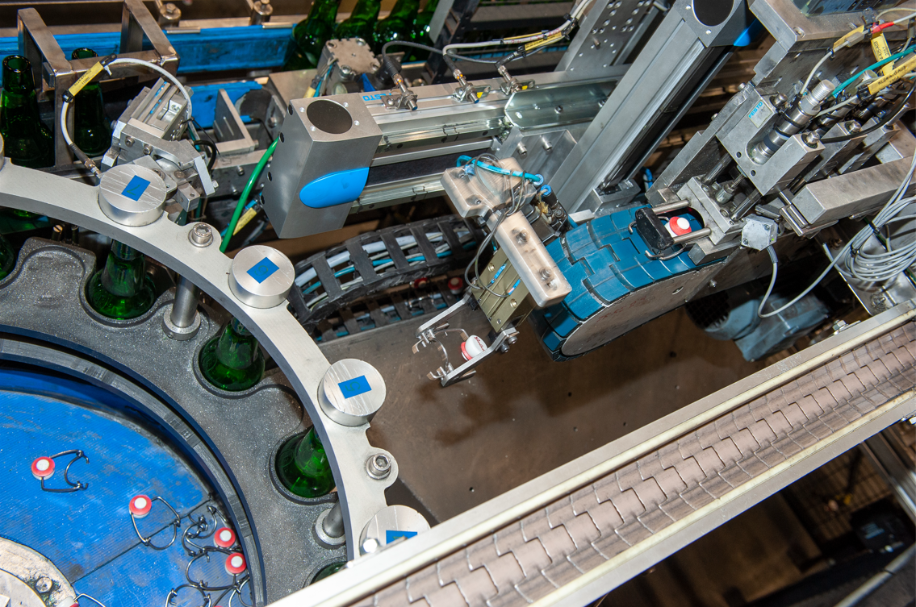

The Grolsch 'swing-top transfer unit' features the new Festo EMMT servo motor and CPX-E automation system and provides approximately 3,800 bottles per hour with a porcelain cap and rubber ring.

About Festo
Festo is a leading international supplier of automation technology with a turnover in 2020 of around €2.84 billion. Festo employs over 20,000 people worldwide and is a proven innovator and problem solver in pneumatic and electrical automation, where it is the performance leader. Festo offers around 30,000 pneumatic and electric products in hundreds of thousands of variants for factory and process automation technology which can be tailored to specific customer needs. Sustainability, reducing its CO2 footprint, digital learning, innovation, performance and speed are the key drivers for the company's future.

Festo Industrial Automation's innovative strength is demonstrated through the launch of around 100 new products every year. The company invests over 8% of its turnover in R&D, resulting in over 2,600 patents held worldwide. For more information about the company's products and UK / Irish services, please visit: www.festo.com/gb and www.festo.com/ie

Festo and Industry 4.0 - Festo has engaged with the Industry 4.0 initiative from its inception: as a user, manufacturer and trainer. As a member of the steering group, the company has taken an active role in defining the core standards such as the RAMI model and the Administration Shell. Festo Didactic has installed Industry 4.0 Cyber-Physical Factory training hardware systems in many leading universities and training centres. It also provides Industry 4.0 training courses for change managers and practical workshops for employees. Industry 4.0 technologies such as OPC-UA communications are embedded in the latest generation products. For more information, go to digital.festo.com

Festo Didactic training delivers training for industry – by industry. Combining Festo's industrial heritage with its future-focused manufacturing and engineering expertise to deliver courses for greater productivity and competitiveness. Offering a wide range of open courses, structured development programmes and tailor-made, customer-specific projects on technology and Industry 4.0. In 2021 Festo launched the industry-leading online training suite, Festo LX. Festo also provides state-of-the-art training equipment solutions for 56,000 industrial companies and educational institutions around the world. More information on Festo training and consulting services can be found at: www.festo-didactic.co.uk

Festo Bionic Learning Network encapsulates the innovative nature of Festo, raising awareness and attracting talent to the company. Exploring the links between nature and technology opens new areas of innovation and demonstrates complex ideas in a stimulating and enjoyable way. Festo works with an alliance of internal R&D, external educational establishments and specialist companies to advance bionic solutions for automation applications of the future. The objective is to benefit from bionics as a source of inspiration and to realise these in industrial automation. For more information about Festo's Bionic Learning Network, please visit: www.festo.com/bionics

For more information please visit www.festo.com

Telephone number for publication: - 01252 775000

Journalist contact:
Alison Jones, Publitek
Tel: 01582 390980
Email: alison.jones@publitek.com

