Simple innovation heralds time and cost savings for machine builders
Date
21.04.22
Our reference
FTO041

Press Information
Simple innovations to improve existing pneumatics technology can make a real difference to the way we build and commission machines, according to industrial automation specialist Festo.

Steve Sands, Head of Product Management at Festo GB, says: “Innovation can come in many forms and isn’t restricted to technical features. Human factors like usability, convenience and safety are tangible areas for development and improvement. Overall costs, machine assembly and build times, on-site commissioning costs and maintenance times are also areas requiring innovative solutions.”

Festo cites the simple cylinder sensor switch as a prime example. These devices are mounted on most pneumatic cylinders and provide sensor feedback. They are most frequently used when the cylinder reaches its advance or retract end-positions and, less frequently, in mid-position: for example, when a cylinder movement has cleared an overlap position. Cylinder switches may appear to be an automation commodity beyond advancement – but there is room for improvement.

“Mounting a cylinder sensor on the bench is straightforward enough, but once the actuator is installed into the machine you often can’t see the end final positions,” explains Sands. “It can be even harder when access is required inside the machine guarding, at height or in difficult to reach locations. In these circumstances, accessing the sensor Allen key position adjustment or observing the indicator LED can be physically impossible.

Clearly, final setting and adjustment of cylinder sensors is problematic and time-consuming, particularly on machines with multiple cylinders, yet it can make a big difference to long-term reliability and operating lifetime. Festo has developed an innovative solution to aid the correct installation of pneumatic cylinders.

Suitable for all compatible T-slot cylinder grooves, the SDBT-MSX is the first auto-teach cylinder switch that learns the required switching position simply by cycling the machine four times during set-up. No in-situ adjustment is required: instead the switch is simply dropped into place in the approximate required position. The fitter sets the sensor up by aligning the cylinder with an integral sensor mark. Once the cylinder is fitted into position on the machine and the sensor is wired in, it’s LEDs will indicate that the switching point is not yet saved. Cycling the machine, including this actuator, just four times enables the self-teach function. The optimum switching position is learnt by the sensor and saved.

This technology has several other benefits for users going beyond the basic, standard operation. These include the ability to manually teach-in a position using the integrated capacitive teach button and the ability to re-assign the switching operation from PNP to NPN and also from Normally Open to Normally Closed operation. Even the switching window can be adjusted from the pre-set 2mm to any length up to 15mm if the application requires it. This is where purchasing, stores and maintenance can gain – one cylinder sensor for all applications.

Concludes Sands: “It is reassuring to know that even in the most commonplace areas of automation, innovation is thriving and will have a real positive impact on users. Faster assembly times, more reliable switching, plus less time stretching, going up ladders or lying under machines have got to be welcome improvements.”

And on the subject of cost, the SDBT-MSX is manufactured in-house by Festo at virtually the same cost as standard sensors. Innovation doesn’t always come at a price.

For more information about Festo products and services, visit: www.festo.com/gb

Ends

The press text and photo(s) can be downloaded from www.festo.co.uk/gbpress

Images and captions

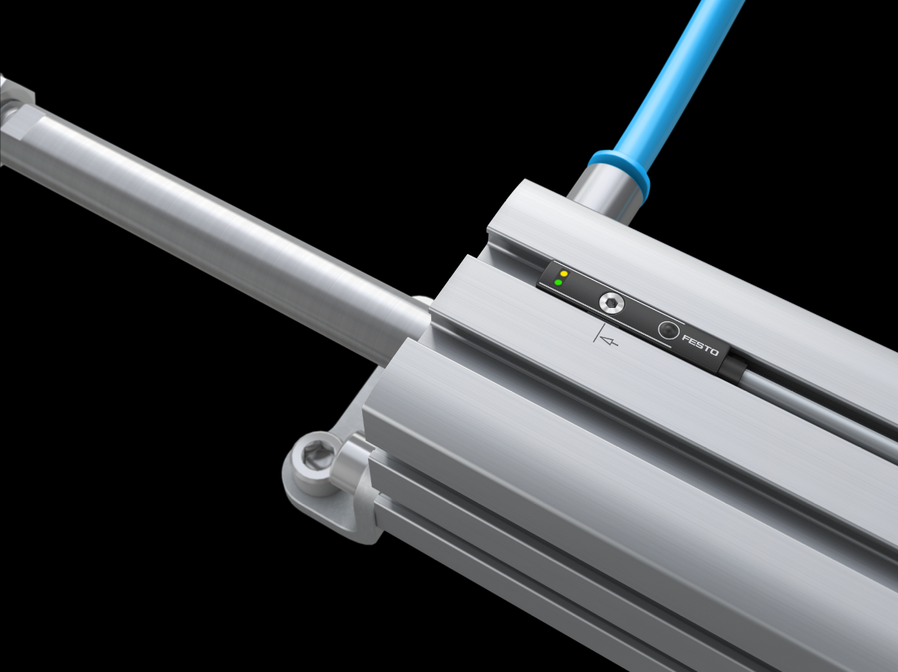

Faster assembly times and more reliable cylinder switching are two advantages of the latest pneumatic innovation from Festo.

About Festo
Festo is a leading international supplier of automation technology with a turnover in 2020 of around €2.84 billion. Festo employs over 20,000 people worldwide and is a proven innovator and problem solver in pneumatic and electrical automation, where it is the performance leader. Festo offers around 30,000 pneumatic and electric products in hundreds of thousands of variants for factory and process automation technology which can be tailored to specific customer needs. Sustainability, reducing its CO2 footprint, digital learning, innovation, performance and speed are the key drivers for the company's future.

Festo Industrial Automation's innovative strength is demonstrated through the launch of around 100 new products every year. The company invests over 8% of its turnover in R&D, resulting in over 2,600 patents held worldwide. For more information about the company's products and UK / Irish services, please visit: www.festo.com/gb and www.festo.com/ie

Festo and Industry 4.0 - Festo has engaged with the Industry 4.0 initiative from its inception: as a user, manufacturer and trainer. As a member of the steering group, the company has taken an active role in defining the core standards such as the RAMI model and the Administration Shell. Festo Didactic has installed Industry 4.0 Cyber-Physical Factory training hardware systems in many leading universities and training centres. It also provides Industry 4.0 training courses for change managers and practical workshops for employees. Industry 4.0 technologies such as OPC-UA communications are embedded in the latest generation products. For more information, go to digital.festo.com

Festo Didactic training delivers training for industry – by industry. Combining Festo's industrial heritage with its future-focused manufacturing and engineering expertise to deliver courses for greater productivity and competitiveness. Offering a wide range of open courses, structured development programmes and tailor-made, customer-specific projects on technology and Industry 4.0. In 2021 Festo launched the industry-leading online training suite, Festo LX. Festo also provides state-of-the-art training equipment solutions for 56,000 industrial companies and educational institutions around the world. More information on Festo training and consulting services can be found at: www.festo-didactic.co.uk

Festo Bionic Learning Network encapsulates the innovative nature of Festo, raising awareness and attracting talent to the company. Exploring the links between nature and technology opens new areas of innovation and demonstrates complex ideas in a stimulating and enjoyable way. Festo works with an alliance of internal R&D, external educational establishments and specialist companies to advance bionic solutions for automation applications of the future. The objective is to benefit from bionics as a source of inspiration and to realise these in industrial automation. For more information about Festo's Bionic Learning Network, please visit: www.festo.com/bionics

For more information please visit www.festo.com

Telephone number for publication: - 01252 775000

Journalist contact:
Alison Jones, Publitek
Tel: 01582 390980
Email: alison.jones@publitek.com

