Festo and PCE Automation help Frugalpac™ increase production of sustainable wine bottles
Date
21.03.22
Our reference
FTO042

Press Information
A collaboration between Festo and PCE Automation has helped recyclable packaging experts Frugalpac Limited to achieve the high throughputs and precision assembly necessary to meet increased demand for its innovative paperboard Frugal Bottle.

Frugal Bottle is the world’s first paper wine and spirits bottle. Its innovative design comprises an outer made from 94% recycled paperboard with an inner food grade pouch. Frugal Bottle is fully recyclable, is five times lighter than glass and has a much lower carbon footprint than traditional wine bottles. It also offers 360-degree branding for better impact on the shelf.

Frugal Bottles are manufactured from two paperboard blanks that are precision cut, glued and then wetted front and back, before being stacked ready for feeding into the bottle forming machine. Achieving the desired throughputs is a major challenge because the glue pathway is complex and must be tailored to the profile of the bottle. In addition, the correct amount of glue has to be applied to prevent malformation or unsightly glue excess on the finished bottle.

Frugalpac had approached an adhesive systems company for a solution, but they were unable to achieve the desired cycle times. Working closely together, PCE Automation and Festo developed a fully automated gluing and wetting line to meet the tight tolerances and complex gluing patterns necessary to deliver throughputs of 630 bottles per hour.

Ronan Quinn, project manager for PCE, says: “The gluing process was more complex than anything we’d encountered before. Tight tolerances on the gluing pattern combined with a short cycle time and critical bead thicknesses were a real challenge. We would usually undertake the entire design and assembly inhouse, but on this occasion Festo supplied the handling gantries to us fully assembled which added real value in terms of component compatibility and commissioning.”

Making it stick
The automation cell provided by PCE Automation requires minimal human intervention. An operator loads the blanks for the front and back of the bottles at the front end. The machine then picks, loads, transfers, glues, transfers again, wets and conveys the prepared blanks into a container at the end of process. The prepared blanks are then transferred to the bottle forming machine.

PCE Automation used the Festo Handling Guide Online (HGO) to design the automation cell. This free online tool dramatically reduces design, assembly and delivery time and enables customers to create a ready-to-install handling system: whether for a single-axis system, a 2D linear and planar surface gantry or a 3D gantry. With just a few clicks, the HGO delivers the right standard handling system, including CAD model, animation, and complete EPLAN schematic documentation. The individual steps (including RFQ, layout, quotation and CAD design), which previously could take 10 to 15 days, can be completed in a matter of minutes. The reduction in design and documentation time enabled PCE to meet Frugalpac’s delivery expectations.

The unique gluing and wetting solution was tested and sized at Festo’s UK Application Centre to prove that the desired cycle times could be achieved. It uses the Festo CPX-E-CEC Controller as the PLC to deliver interpolated soft motion, controlling multiple axes at the same time to achieve the complex curves on the glue paths. Festo CMMT servo controllers feature in the three handling systems for precise and repeatable loading, gluing and unloading. Festo core pneumatics products, valve terminals and process valves are also used extensively throughout the gluing and wetting system.

Bottling success
The PCE automation cell needed to achieve a cycle time of just 19 seconds to meet Frugalpac’s requirements. The gluing and wetting solution delivers a gluing time that is 50% faster than specified, enabling the entire machine to meet the overall cycle times required. It achieves this by batch-gluing eight bottles simultaneously, with different glue patterns being applied to the front and back blanks.

John-Paul Grogan, Product Director at Frugalpac, says: “Frugalpac is committed to the development of more sustainable packaging. The application of automation in the production of Frugal Bottle will help us to achieve our aim of reducing the carbon of wine and spirits packaging.”

Festo and PCE are now working with Frugalpac to develop an automated method for the forming of the Frugal Bottle itself.

Ends

For more information about Festo products and services, visit: www.festo.com/gb

The press text and photo(s) can be downloaded from www.festo.co.uk/gbpress

Images and captions:

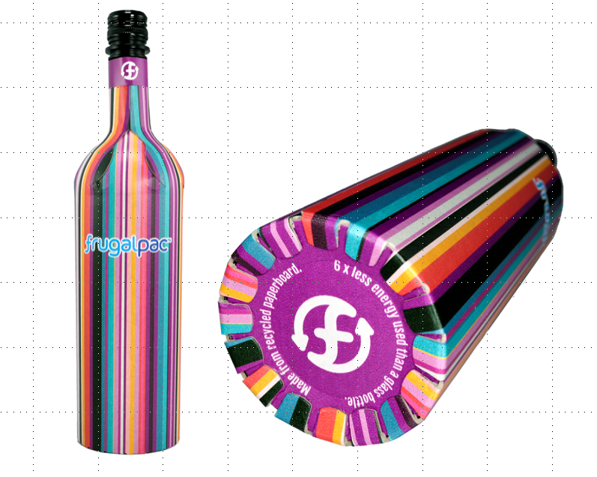
Festo automation is helping to increase production of Frugal Bottle, the world’s first paper wine and spirits bottle.

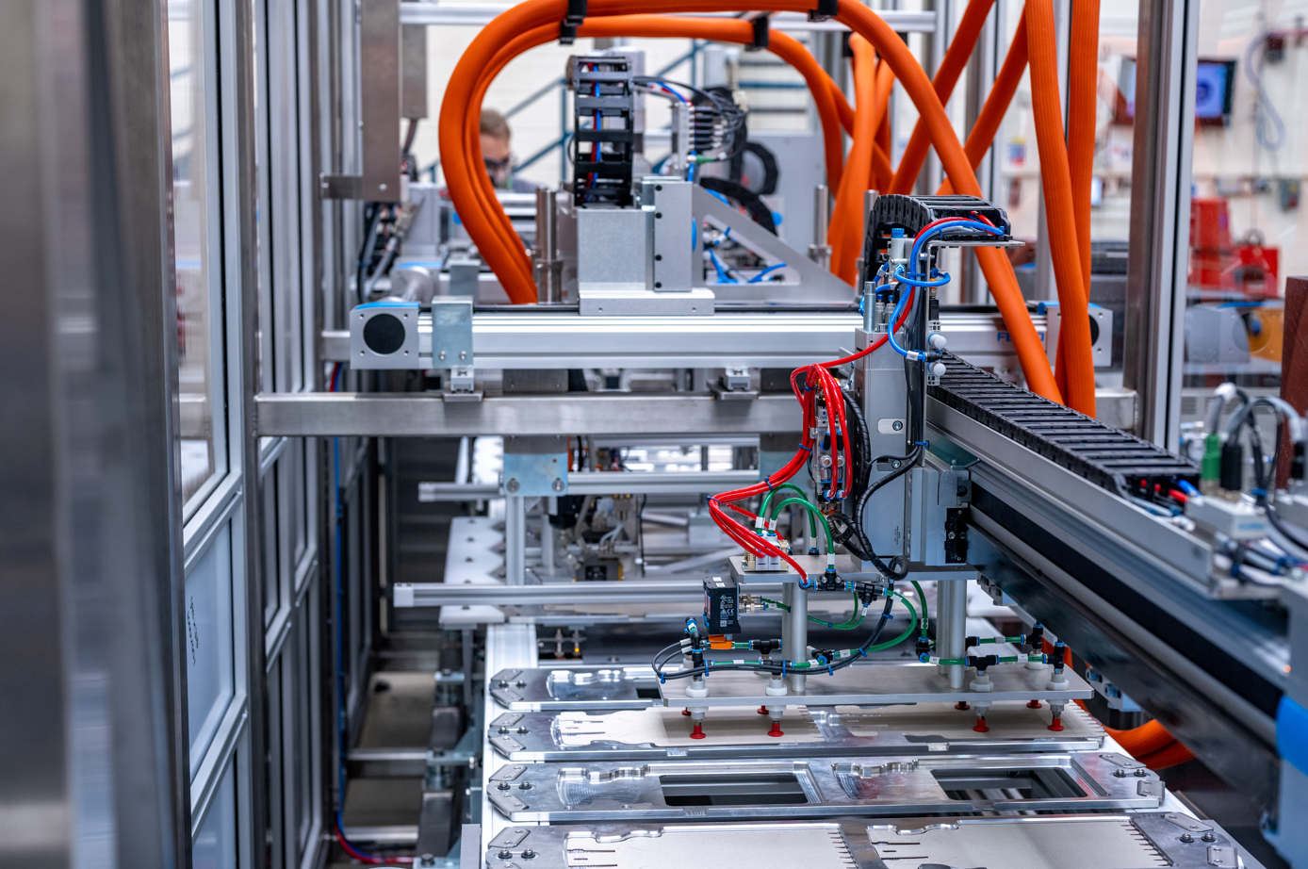

The Frugal Bottle automation cell was designed by PCE Automation using Festo’s Handling Guide Online (HGO) to speed up design and delivery times.
About PCE Automation Ltd

Formed in 1961, PCE Automation Ltd are at the forefront of UK Automation and UK Manufacturing, providing a vast range of bespoke turnkey automation solutions. PCE have built a worldwide reputation for innovation and quality, underpinned by ISO 9001 and Safe Contractor accreditations, as well as a Queens Award for Enterprise 2020 in International Trade.

PCE manufacture stand alone and complete systems primarily for clients within the ocular, medical, pharmaceutical, clean room/laboratory and FMCG (Fast Moving Consumer Goods) sectors, as well as Industrial Automation. PCE can boast complete in-house skills and capabilities to design, project manage, manufacture, program, install, commission and service; meaning shorter project lead times through reduced outsourcing, helping customers achieve a swifter ROI.

PCE Automation is a founding member of the PCE GROUP of Companies. For more information, visit: www.pce-automation.co.uk

About Festo

Festo is a leading international supplier of automation technology with a turnover in 2021 of around €3.35 billion. Festo employs over 20,700 people worldwide and is a proven innovator and problem solver in pneumatic and electrical automation, where it is the performance leader. Festo offers around 30,000 pneumatic and electric products in hundreds of thousands of variants for factory and process automation technology, many of which can be tailored to specific customer needs. Sustainability, reducing its CO_{2,} footprint, digital learning, innovation, performance and speed are the key drivers for the company's future.

Festo Industrial Automation's innovative strength is demonstrated through the launch of around 100 new products every year. The company invests over 7% of its turnover in R&D, resulting in over 2,600 patents held worldwide. For more information about the company's products and UK / Irish services, please visit: www.festo.com/gb and www.festo.com/ie

Festo and Industry 4.0 - Festo has engaged with the Industry 4.0 initiative from its inception: as a user, manufacturer and trainer. As a member of the steering group, the company has taken an active role in defining the core standards such as the RAMI model and the Administration Shell. Festo Didactic has installed Industry 4.0 Cyber-Physical Factory training hardware systems in many leading universities and training centres. It also provides Industry 4.0 training courses for change managers and practical workshops for employees. Industry 4.0 technologies such as OPC-UA communications are embedded in the latest generation products. For more information, go to www.festo.com/digitalisation

Festo Didactic training delivers training for industry – by industry. Combining Festo's industrial heritage with its future-focused manufacturing and engineering expertise to deliver courses for greater productivity and competitiveness. Offering a wide range of open courses, structured development programmes and tailor-made, customer-specific projects on technology and Industry 4.0. In 2021 Festo launched the industry-leading online training suite, Festo LX. Festo also provides state-of-the-art training equipment solutions for industrial companies and educational institutions around the world. Festo Didactic has around 60,000 education customers worldwide. More information on Festo training and consulting services can be found at: www.festo.com/didactic

Festo Bionic Learning Network encapsulates the innovative nature of Festo, raising awareness and attracting talent to the company. Exploring the links between nature and technology opens new areas of innovation and demonstrates complex ideas in a stimulating and enjoyable way. Festo works with an alliance of internal R&D, external educational establishments and specialist companies to advance bionic solutions for automation applications of the future. The objective is to benefit from bionics as a source of inspiration and to realise these in industrial automation. For more information about Festo's Bionic Learning Network, please visit: www.festo.com/bionics

For more information, please visit www.festo.com

Telephone number for publication: - 01252 775000

Journalist contact:
Alison Jones, Publitek
Tel: 01582 390980
Email: alison.jones@publitek.com

