Design Cartesian robots in minutes – complete with digital documentation – with the Handling Guide Online from Festo
Date
01.02.22
Our reference
FTO043

Press Information
Festo has extended the capabilities of its Handling Guide Online (HGO) to include 3D cantilever systems in addition to linear, planar surface and 3D handling systems. These improvements mean that design engineers can now plan extremely compact or extremely dynamic Cartesian robots in a matter of minutes using the HGO’s intuitive configuration and ordering software. They can also benefit from the complete documentation package, including circuit diagram service from Eplan and commissioning files.

The Handling Guide Online is free to use and has been developed by Festo to enable design engineers to create ready-to-install handling systems in record time, whether they are 2D or 3D gantries and now 3D cantilever systems. This smart and intuitive tool can be used to configure and create new system solutions without disrupting the value chain. This has been made possible through the integration of the configuration and ordering platform with Festo’s online product catalogue. As a result, HGO users are just a few mouse clicks away from the right standard handling system, including CAD model. The individual steps including RFQ, layout, quotation and CAD design, which previously may have taken 10 to 15 days, can now be done in just a few minutes using the Handling Guide Online.

Festo’s HGO also cuts assembly and delivery times from a typical two months to just a few weeks. New standard products are also shortening set-up, parameterisation and commissioning times. Machine and system builders are therefore able to reduce their time to market for integrated handling systems by around 70%. Thanks to this engineering tool, design engineers have more time and space for creativity when planning and project engineering their companies' core areas of technological expertise.

At the end of the design process a single click transmits the order to Festo. The handling experts from Festo deliver a ready-to-install system, including all user documentation in accordance with the EU Machinery Directive, directly to the machine or plant in no time at all.

Error-free documentation and Eplan
Festo’s Schematic Solution software enables HGO users to save valuable engineering time by creating all the necessary documentation on their behalf. Generally, creating an Eplan project can take several hours and, depending on the complexity, can be prone to input errors. Schematic Solution automates many of the process steps, freeing up time for creative tasks whilst creating complete, error-free project documentation. The electrical circuit and pneumatic diagrams can be purchased as an Eplan project via Schematic Solution in the Festo App World.

Data is only entered once and is then managed consistently throughout the entire process, resulting in an Eplan project with a unique system ID for each individual handling system. Error-free documentation for the configured handling system with a mechatronic image of the configured motors and drives, such as EMMT-AS motors and CMMT-AS servo drives, is generated at the click of a key. Thanks to the integration of the documentation, configuring handling systems using Festo’s HGO is not only more reliable, but also less expensive because of the valuable time savings.

Efficient commissioning
Festo also makes commissioning faster. The commissioning files are custom created based on the user input and the calculated system, which are loaded directly via the Festo Automation Suite into the motor controller. The commissioning file contains the set of values specifically for the particular handling system, consisting of axis dimensions, motor characteristics, feed constants and dynamic data. The controller settings are automatically calculated on the basis of the payload, the dead weight and the system dynamics entered by the user.

Driving digitalisation
With the Handling Guide Online, Festo is driving digitalisation, supporting its customers to enter the age of Industry 4.0. As an automation expert Festo is combining its extensive knowledge of industrial applications with the latest developments in information technology to realise online applications for industrial automation. Festo is also using digital communication to support its customers throughout the Digital Customer Journey. This digital journey guides customers reliably and comprehensively through the Festo portfolio, from information procurement and configuration through ordering and delivery to commissioning and maintenance and on to technical training offered by Festo Didactic.

For more information about Festo products and services, visit: www.festo.com/gb

Ends

The press text and photo(s) can be downloaded from www.festo.co.uk/gbpress

Images and captions:

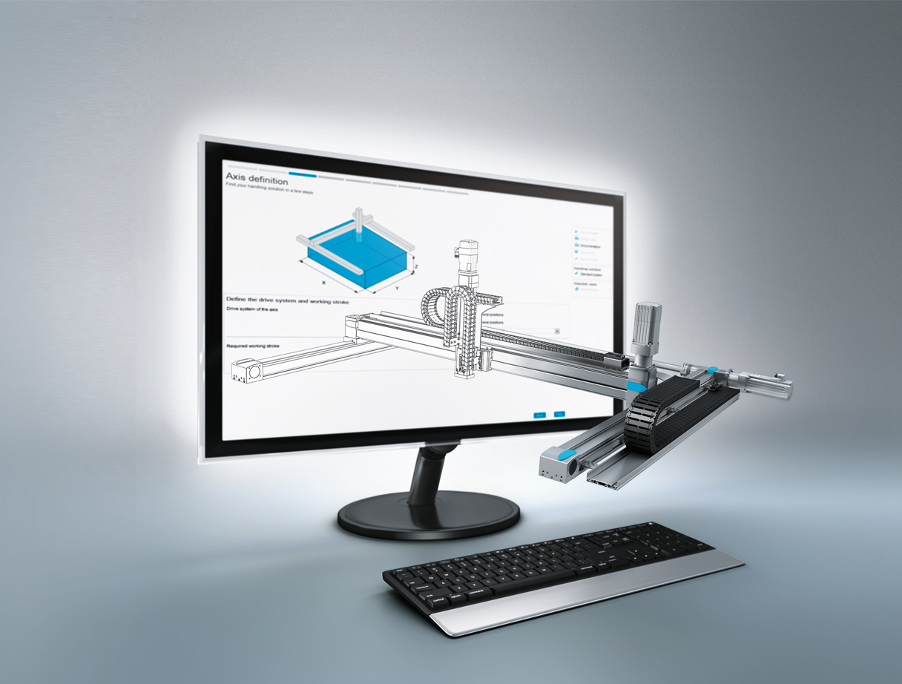

Extremely compact or extremely dynamic Cartesian robots can now be configured in a matter of minutes using Festo’s Handling Guide Online.

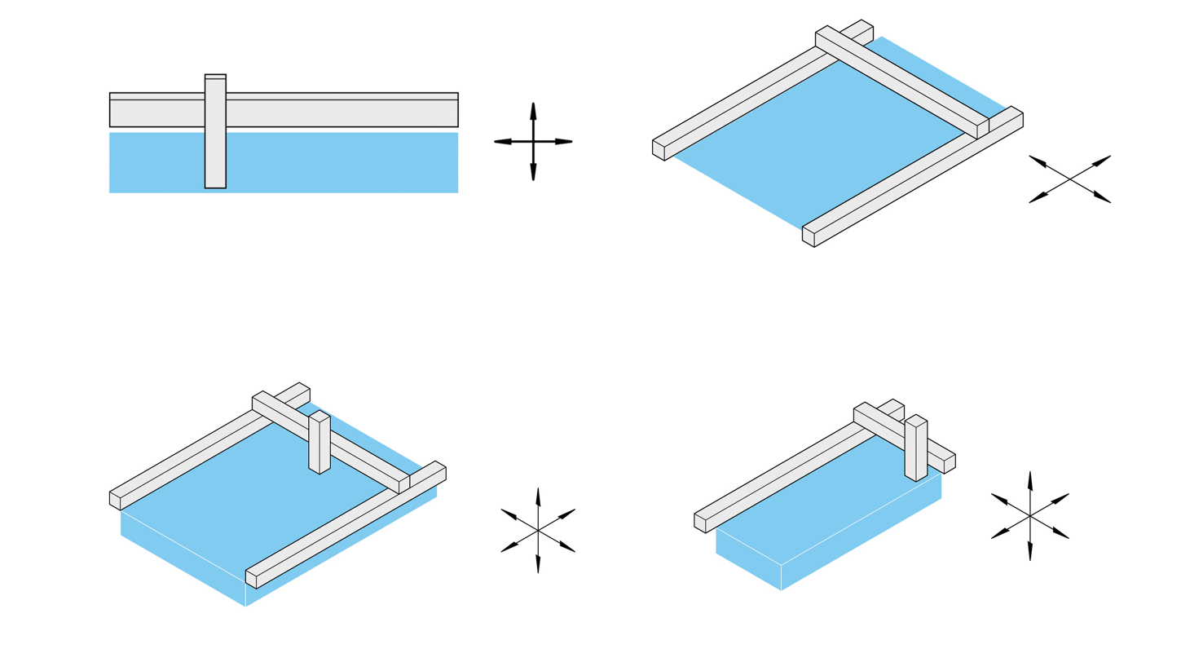

Dynamic cartesian configurations in the Handling Guide Online.
Top row: 2D linear and gantry robots. Bottom row: 3D gantry and cantilever systems.

About Festo
Festo is a leading international supplier of automation technology with a turnover in 2020 of around €2.84 billion. Festo employs over 20,000 people worldwide and is a proven innovator and problem solver in pneumatic and electrical automation, where it is the performance leader. Festo offers around 30,000 pneumatic and electric products in hundreds of thousands of variants for factory and process automation technology which can be tailored to specific customer needs. Sustainability, reducing its CO2 footprint, digital learning, innovation, performance and speed are the key drivers for the company's future.

Festo Industrial Automation's innovative strength is demonstrated through the launch of around 100 new products every year. The company invests over 8% of its turnover in R&D, resulting in over 2,600 patents held worldwide. For more information about the company's products and UK / Irish services, please visit: www.festo.com/gb and www.festo.com/ie

Festo and Industry 4.0 - Festo has engaged with the Industry 4.0 initiative from its inception: as a user, manufacturer and trainer. As a member of the steering group, the company has taken an active role in defining the core standards such as the RAMI model and the Administration Shell. Festo Didactic has installed Industry 4.0 Cyber-Physical Factory training hardware systems in many leading universities and training centres. It also provides Industry 4.0 training courses for change managers and practical workshops for employees. Industry 4.0 technologies such as OPC-UA communications are embedded in the latest generation products. For more information, go to digital.festo.com

Festo Didactic training delivers training for industry – by industry. Combining Festo's industrial heritage with its future-focused manufacturing and engineering expertise to deliver courses for greater productivity and competitiveness. Offering a wide range of open courses, structured development programmes and tailor-made, customer-specific projects on technology and Industry 4.0. In 2021 Festo launched the industry-leading online training suite, Festo LX. Festo also provides state-of-the-art training equipment solutions for 56,000 industrial companies and educational institutions around the world. More information on Festo training and consulting services can be found at: www.festo-didactic.co.uk

Festo Bionic Learning Network encapsulates the innovative nature of Festo, raising awareness and attracting talent to the company. Exploring the links between nature and technology opens new areas of innovation and demonstrates complex ideas in a stimulating and enjoyable way. Festo works with an alliance of internal R&D, external educational establishments and specialist companies to advance bionic solutions for automation applications of the future. The objective is to benefit from bionics as a source of inspiration and to realise these in industrial automation. For more information about Festo's Bionic Learning Network, please visit: www.festo.com/bionics

For more information please visit www.festo.com

Telephone number for publication: - 01252 775000

Journalist contact:
Alison Jones, Publitek
Tel: 01582 390980
Email: alison.jones@publitek.com

