Festo Introduces AI-Enabled Predictive Maintenance
at Pack Expo

Festo also debuts innovative palletizing kits, an adaptive gripper for fragile foods, and condition-monitoring.

ISLANDIA, N.Y., September 24, 2025 — Festo introduces its AI-enabled monitoring and predictive maintenance systems Festo AX Motion Insights Electric and Festo AX Motion Insights Pneumatic at Pack Expo. (Festo Pack Expo Booth #N-9018, Las Vegas Convention Center, September 29-October 1)
Festo AX Motion Insights Electric and Pneumatic are cost-effective, easy-to-use solutions for preventing costly unscheduled machine downtime through monitoring of electric axes, servo drives, and pneumatic cylinders for wear and anomalies. These AI-based industrial apps ensure operations are more reliable, efficient, and ultimately more profitable.
The company also introduces FPaKit, a gantry-style palletizing package that gives machine builders the opportunity to cost-effectively participate in the expanding automated palletizing market with a feature-rich, high-performance solution.
The new HPSX universal adaptive gripper is a groundbreaking hygienic soft gripper engineered to handle delicate, irregularly shaped, and hygienically sensitive products. Gripper fingers are produced from a soft silicone-based material, making them ideal for items that are easily damaged. HPSX can perform multiple picks per second.
The new Festo AX Data Access app is a protocol translator converting data from proprietary Festo operational technology (OT) protocols into the industry-standard MQTT messaging protocol. Festo AX Data Access offers a simple way to set up condition-monitoring and energy-savings solutions based on operational data gleaned from Festo components. Data Access is a plug-and-play solution that streamlines asset management and reduces IT administration.
AI-Powered Automation Monitoring for Electric and Pneumatic Systems

The Motion Insights Electric and Pneumatic apps enable maintenance teams to schedule tasks in advance, significantly reducing the risk of unexpected downtime. These platforms offer the flexibility of on-premises computing, giving end users full control over their data and deployment. Motion Insights Pneumatic is an open system that works with both Festo and third-party cylinders. Motion Insights Electric works with Festo axes and multiprotocol servo drives.
The AX platform features ease of use and seamless integration, opening the door for customers to embrace without worry today's AI, data-driven solutions, and digital transformation. Machined builders can choose to monitor both electric and pneumatic components or monitor a single system.
A critical element of Motion Insights is its integration with Festo’s Smartenance maintenance management system. Motion Insights works in tandem with Smartenance; the insights apps identify when maintenance is needed, and Smartenance manages the resulting tasks. The integration of the two creates a cohesive, end-to-end workflow that ensures predictive insights are not just seen but also efficiently acted upon.
FPaKit slashes engineering costs and time to market for OEMs

The Festo FPaKit is as close to a gantry palletizer in a box as possible. FPaKits include pre-set, sized, and assembled axes and motors (Z-axis motor, including a brake), multiprotocol servo drives, hybrid controller with pre-installed palletizing software, cables, software license, and user interface. Machine builders select an FPaKit by load capacity: 44 lbs (20 kg) for the LW2x kit, 66 lbs (30 kg) for the LW3x kit, and up to 110 lbs (50 kg) for the MW4x customized kit. These palletizers feature speeds of 4 to 10 boxes per minute.
In a practical application of the FPaKit, CODI Manufacturing, Littleton, Colorado, showcases in the Festo booth its new line of gantry palletizers, Flex Stack, which is based on the FPaKit. CODI shows its Flex Stack Pro series, an MW4x custom FPaKit, configured as a palletizer/de-palletizer.
CODI said Flex Stack gantry-style palletizers compare in price to cobot palletizers but deliver higher performance and a lower total cost of ownership. According to CODI, ROI in one year is doable for operations switching from labor-intensive palletizing to an automated Flex Stack option.
Hygienic soft gripper revolutionizes food and pharma workflows
The design of the HPSX pneumatic gripper is a significant advancement over traditional, rigid gripping solutions and addresses long-standing challenges in automating tasks in the food, pharmaceutical, and cosmetics industries, where product damage is a concern. HPSX grippers can withstand acceleration up to 15 g-force while holding up to 1.1 lbs.
The HPSX is highly corrosion resistant and features a sanitary design that makes it easy to clean and maintain. It has a high-pressure washdown rating of IP69k, which ensures it meets food safety regulations and cleanliness standards. The materials used are food-grade and metal-detectable.
Festo AX Data Access Connects the Shop Floor to the Cloud
The new Festo AX Data Access app acts as a protocol translator. OT data is accessed from such components as Festo valve manifolds, servo drives, energy efficiency modules, and remote I/O. The system offers simple commissioning. There is no need to intervene in the PLC program to set up or operate AX Data Access. The app is as ideal for new systems as it is for retrofitting existing ones. Festo AX Data Access is purchased as a perpetual license for 10, 100, or 1,000 Festo components through Festo App World.
Visit the Festo Booth #N-9018 while at Pack Expo to see these products. Contact a Festo sales representative or Festo distribution partner to learn more about Festo AX Motion Insights Electric and Pneumatic, FPaKit, HSPX, and Festo AX Data Access. For more information on the advantages of working within the Festo ecosystem to leverage less engineering overhead, faster time to market, seamless connectivity, and high-quality components, visit www.festo.com.
###
Download images here
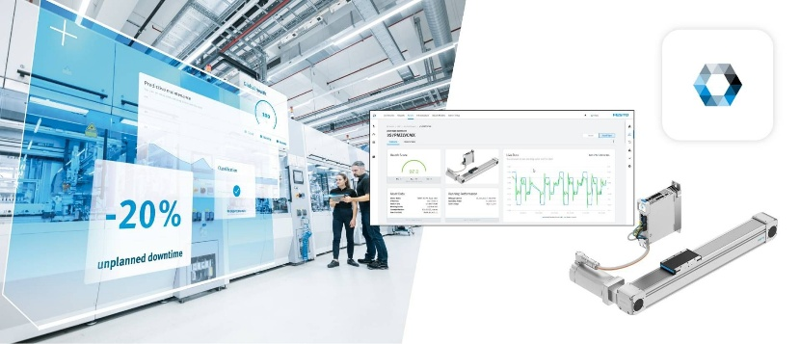
AX Motion Insights Electric is a cost-effective, easy-to-use solution for preventing costly unscheduled machine downtime through its monitoring of electric axes and servo drives.

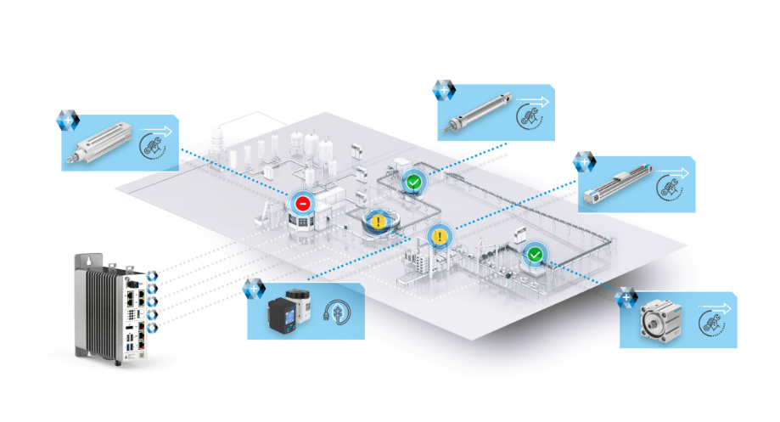
AX Motion Insights Pneumatic is an open system and operates with Festo and third-party cylinders.

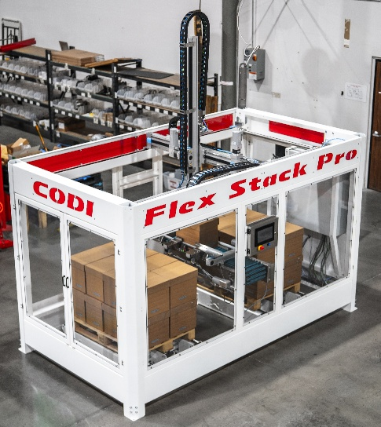
The new Flex Stack series of gantry palletizers/de-palletizers is based on the new FPaKit of gantry-style palletizers and is displayed at the Festo Pack Expo 2025 booth #N-9018.

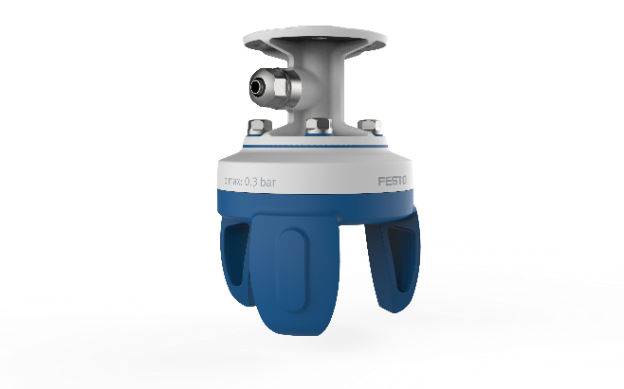
The HPSX soft gripper is food safe, features a sanitary design, and handles a wide variety of objects with different shapes and sizes without requiring a tool change.

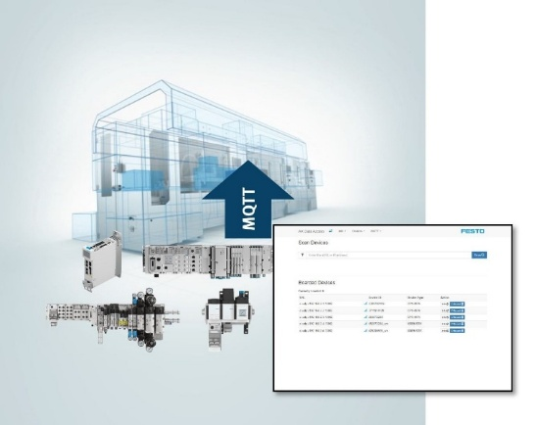
Festo AX Data Access offers condition-monitoring and energy-savings solutions based on operational data gleaned from Festo components.

About Festo U.S.
Festo is a leading manufacturer of pneumatic and electromechanical systems, components, and controls for process and industrial automation. For 100 years with more than 50 in the U.S., Festo Corporation has continuously elevated the state of manufacturing with innovations and optimized motion control solutions that deliver higher performing, more profitable automated manufacturing and processing equipment. Through advanced technical and industrial education, Festo Didactic Learning Systems and its partners prepare workers for current and future manufacturing technologies.
Connect with Festo: Facebook, LinkedIn, and YouTube

