Legal form:
Limited partnership
Registered office: Esslingen a. N.
Registry court Stuttgart
HRA 211583
Value added tax id. number:
DE 145 339 206
General partner:
Festo Management SE
Registered office: Frankfurt a.M.
Registry court Frankfurt a.M.
HRB 115998
Management Board:
Dipl.-Ing. Gerhard Borho
Dipl.-Ing. Dr. h.c. Oliver D. Jung (Chairman)
Dr. Ansgar Kriwet
Dr. Frank Melzer
Dipl.-Ing. (FH) Frank Notz
Dr. Jaroslav Patka
Chairman of the Supervisory Board:
Dr. Friedrich Eichiner
Date
November 17th, 2021

Festo and FlexFactory bundle their solutions for
as a Service business models
Digital Production as a Service brings manufacturing, R&D and finance into harmony.
Festo SE & Co. KG and the joint venture FlexFactory GmbH of MHP, Munich Re and Porsche are consolidating their strategic partnership and entering the market with a joint offering for machine and plant manufacturers as well as plant and equipment operators. The aim of the partnership is to enable the production of a wide range of product variants in a more flexible and cost-efficient manner.

Shorter product life cycles require flexible machine and plant concepts. This is the only way to reduce business and operational risks during investment and operation. Festo and FlexFactory support the development of flexible production, realised in an innovative "as a service" business model. "Maintenance as a Service" or "Equipment as a Service" models are essential components of this offer. This creates a flexible and scalable production concept that enables manufacturing of different product variants within a production line through "pay per part" or "pay per use" models. This significantly reduces financial risks compared to conventional concepts.

As the market leader in automation technology, Festo provides both its experience in production automation and its extensive range of components from pneumatic and electrical control and drive technology. In addition, Festo's AI-based software solutions, such as Festo AX and Smartenance, help to evaluate machine data and provide insights into the machine status to avoid failures.

FlexFactory, a joint venture between MHP, Munich Re and Porsche, acts as a business enabler and orchestrator. It does not provide its own production lines but offers the knowledge and corresponding services to set up a flexible production as a service concept from a single source: "Digital Production as a Service". In addition, it provides support in the actual implementation of the specific customer project.

To support machine and plant builders in the expansion and transformation of their business model, the joint offer within the partnership covers three solutions that build upon each other:

- Deep data analytics – the implementation of a "Digital Financial Twin" that enables better insights, optimised production processes and higher profitability through plant data from Festo's maintenance solution Smartenance.
- Predictive maintenance and innovative insurance concepts – enabling digital risk transfer solutions based on condition data.
- Complete transformation towards an "as a service" business model – evolving into a provider of guaranteed results, for example through quality guarantees, maintenance flat rates or output rates.

In a joint development project, both companies have tested the combination of their product offerings in Festo's technology factory at Scharnhausen: In the pilot, Festo's maintenance software Smartenance collects data and makes it available to FlexFactory's Risk Balance Board via a so-called Digital Financial Twin. This allows individual process steps on the shop floor to be evaluated and continuously monitored in near real time. The aim is to increase the productivity and profitability of the machines and systems through early intervention.

"Festo's expertise in automation technology for machines and systems makes it an ideal partner for the transformation of production towards an innovative "as a service" business model – a model we are accelerating," says Dr Phillipp Hypko, Managing Director at FlexFactory. "In the implementation of a Digital Financial Twin, Festo's AI-based software solutions are very valuable because they allow us to calculate the offers in a more differentiated way. In this way, the positive effects of an "as a service" model come into effect even better," emphasises Philip Plattmeier, Managing Director at FlexFactory.

"FlexFactory's innovative offer is unique on the market. For us as a manufacturer of components and software in the field of automation technology, it is important to be involved right from the beginning in order to be able to help shape service-based offerings. In this way, we help our customers with their business transformation towards Industry 4.0," says Dr Oliver Niese, Vice President Digital Business at Festo.

About Festo:
Festo SE & Co. KG is a global player and an independent family-owned company headquartered in Esslingen am Neckar, Germany. The company supplies pneumatic and electric automation technology to 300,000 factory and process automation customers in over 35 industries. Its products and services are available in 176 countries. Festo offers, among others, solutions for predictive maintenance, predictive quality and predictive energy with its AI-based software suite Festo AX and a mobile and digital maintenance management system with its software as a service product Smartenance.

www.festo.com

About FlexFactory:
As a joint venture of MHP, Munich Re and Porsche, FlexFactory GmbH offers a package of services by bundling expertise in digitalisation, flexible manufacturing, and financial business model transformation. FlexFactory's licensed product offering includes the Risk Balance Board, a scalable concept that enables a Digital Financial Twin with parametric guarantees as well as new service models and provides informative dashboards for financial insights into machinery and equipment.

www.flexfactory.tech

Further information:
Press text and images are also available online at www.festo.com/press

Contact:
Festo SE & Co. KG
Maren Karlin, Corporate Communication - Technology
Ruiter Straße 82
73734 Esslingen, Germany
Tel.: +49 (0) 711 / 347-55299
Maren.karlin@festo.com or presse@festo.com

Press Images – Overview:
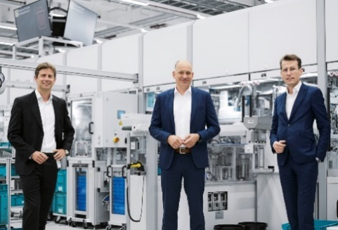
Title image Festo and FlexFactory
(Festo SE & Co. KG)
Caption: The aim of the partnership between Festo and FlexFactory is to enable the production of a wide range of product variants in a more flexible and cost-efficient manner.

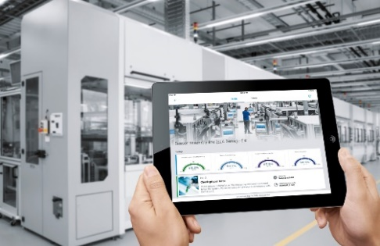
Image Dahsboard Festo_FlexFactory
(Festo SE & Co. KG)
Caption: Festo's maintenance software Smartenance collects data and makes it available to FlexFactory's Risk Balance Board via a Digital Financial Twin. This allows individual process steps on the shop floor to be evaluated and continuously monitored in near real time.

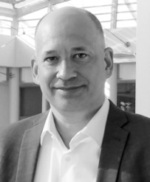
Image Dr Oliver Niese (Festo SE & Co. KG)
Caption: Dr Oliver Niese, Vice President Digital Business Festo SE & Co. KG

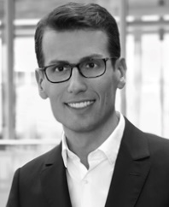
Image Dr Phillipp Hypko (FlexFactory GmbH)
Caption: Dr Phillipp Hypko, Managing Director FlexFactory GmbH

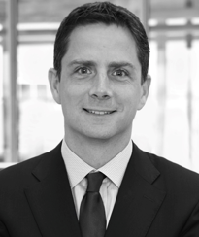
Image Philip Plattmeier (FlexFactory GmbH)
Caption: Philip Plattmeier, Managing Director FlexFactory GmbH

