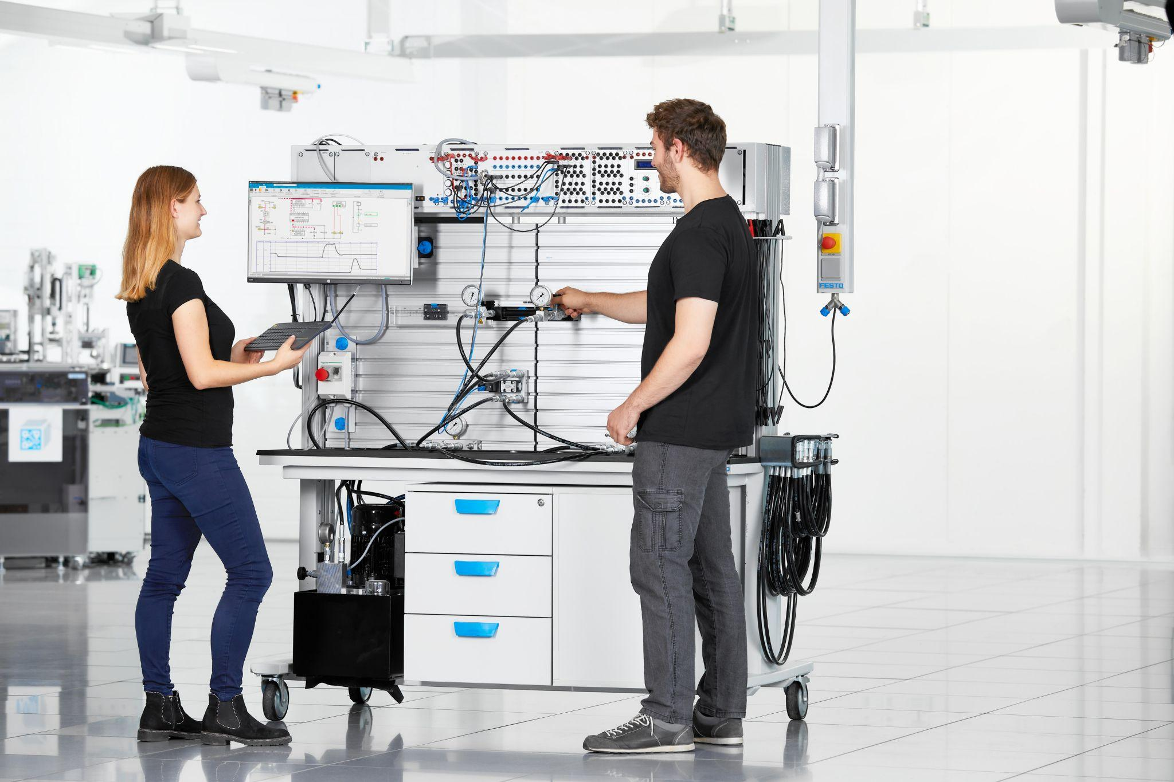

September 16, 2025

Festo Didactic Showcases 60 Years of Innovation in Career and Technical Education at Pack Expo 2025

From ‘Impossible to Implemented’: Festo heads to Pack Expo to show employers and educators how to close the skills gap and accelerate industrial workforce development.

Visit booth #N-9018 from September 29 – October 1

LAS VEGAS, NEVADA - Festo Didactic North America is heading to Pack Expo with advanced training solutions for the packaging industry. Pack Expo is the premier event for packaging and processing innovation in the United States. Festo Didactic will showcase its hands-on learning systems built to simulate real-life industrial environments, and help workers acquire the in-demand skills needed for the future of work. Pack Expo registered attendees are encouraged to explore Festo’s innovative product range at booth #N-9018 from September 29 to October 1.
As a global automation company celebrating its centennial year, and its 60th year as a trailblazer in career and technical education, Festo is uniquely positioned to address the critical need for upskilling the industrial workforce. Over the years, Didactic has developed an impressive lineup of comprehensive Industry 4.0 products and learning systems designed specifically for employers and instructors in need of advanced training methods.
With the manufacturing and packaging industries undergoing rapid technological transformation, the integration of advanced automation, robotics, and AI requires a workforce that is not only skilled but also adaptable. Festo Didactic recognizes this challenge, and therefore provides the training guidance needed to strengthen competencies in key areas such as automation, mechatronics, robotics, and fluid power.
“We fully understand the challenges employers are facing when it comes to finding qualified workers,” said Karolyn Ellingson, Head of Industrial Workforce Development for Festo Didactic North America. “Festo has a longstanding history of delivering industry-aligned education and job training that’s proven effective in qualifying and upskilling individuals for highly-skilled technical work.”
Ellingson added, “Forming strategic alliances, such as Festo’s partnership with The Association for Packaging and Processing Technologies (PMMI), fuels our ability and capacity to follow through and deliver on closing the STEM skills gap, preparing the next generation for success.”
PMMI and Festo Didactic work together to provide PMMI members and education partners with technical training and certification programs aligned with industry standards. The collaboration between Festo and PMMI has helped many companies create tailored internal training programs that ensure their workforce is equipped to handle the latest technologies.

“Equipping emerging talent for the future of work creates a ripple effect, which leads to empowering industrial teams everywhere. That’s what Festo aims to do, not only for the packaging industry, but for automation-powered businesses worldwide,” said Mark Walters, Industry Manager, End of Line Packaging for Festo North America.

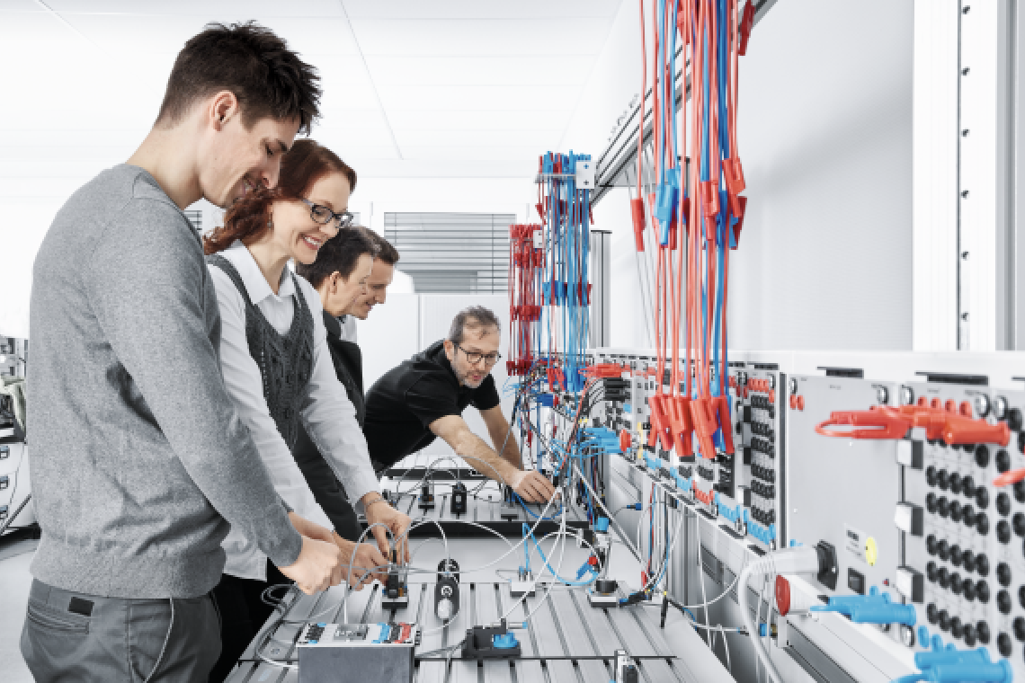

At the booth, Festo will feature:

- Industrial Workforce Development training solutions, and hands-on learning systems from Festo Didactic.
- Smarter Electric Automation and Pneumatic Solutions for efficiency and precision in packaging operations.
- Palletizing & Material Handling with compact gantries and smart software for efficient palletizing.
- Exceptional Guide System Durability with high-speed 2D Pick & Place systems.
- Vacuum & Gripping Solutions for reliable handling and diverse packaging needs.
- Safety, Motion Control & Remote I/O with simplified motion systems like the VTUX and CPX-AP-A-EP for smarter automation in food and packaging operations.
- Festo's Fabco Air brand offers a comprehensive range of actuators, valves, and air preparation products to meet the needs of industries that require inch-based solutions.
- Festo AX Industrial Intelligence is an advanced system that collects real-time production data and uses AI to analyze it, helping companies reduce downtimes by 25%, cut waste by 20%, and reduce leakages by up to 65%.
To learn how to elevate your packaging strategy and automation needs, please fill out this form to schedule a one-on-one consultation with a Festo expert during Pack Expo.

###

Festo leverages its automation expertise to provide comprehensive industrial and technical education solutions. Festo Didactic is committed to providing educators and employers with the hands-on training, digital coursework and blended learning solutions needed to close the STEM skills gap. Our lab equipment, curriculum and certification programs are thoughtfully designed to support various learning pathways and on-the-job training. With over 30,000+ certifications issued and 36,000 Festo-equipped educational institutions, Festo Didactic and its partners are preparing students and employees for the future of work.

For more information, visit Festo.com.

Media Contact
Natasha Gosine, Head of Marketing, North America
natasha.gosine@festo.com
905-614-4611

